**GRADE 7 AGRICULTURE**

**Preliminary Practice Tests**

**Specimen Examinations Zimsec Past Exam Papers**

##### Individual Tuition Centre

Foreword

The **Individual Tuition Centre** was established in 2011 with the sole aim of offering tailor made tutorials for Primary and Secondary students. We have grown to become a force to reckon with in Individual Tutoring.

Tutorials are offered as remedial lessons, crash programs or full time.

Due to our quest to continue to improve the academic performance of students nationwide, we source, compile and print past papers, revision guides and answer booklets for students (primary, secondary, Cambridge and Zimsec).

While every effort is made to ensure the accuracy and reliability of suggested answers, where applicable, the **Individual Tuition Centre** cannot be held liable for any errors that may inadvertently occur. Highly experienced teachers and examiners contribute in the production of these question and answer booklets.

Do not hesitate to contact us if you have any contribution insofar as the production and distribution of these documents is concerned.

**Salanny Mhlanga (Mr) Principal**

***Prepared at: Suppliers of Past Paper Booklets:***

*Individual Tuition Centre ZIMSEC Grade 7 all subjects*

*Primary, Secondary & Professional tutors CHISZ Entrance tests*

*1 Chelmsford Road, Belgravia, Harare CAMBRIDGE Primary Checkpoint*

*Email:* [*info@itc.ac.zw*](mailto:info@itc.ac.zw) *CAMBRIDGE Form 2 Checkpoint*

*Cell:* ***0773 282 117*** *CAMBRIDGE IGCSE and O Level*

*Office :* ***0242 304271*** *ZIMSEC O’ and A’ Level*

# GRADE 7 AGRICULTURE

## SECTION A

### Preliminary Practice Tests

#### TEST 1

1. What do you understand by the term agriculture? [2]
2. State 2 reasons why agriculture is essential. [2]
3. State one conservation technique that can be used to prevent soil erosion. [1]
4. Define the term skilled worker and give an example. [3]
5. What is a rabbit’s fur used for? [1]
6. State 3 ways in which soil is important to agriculture. [3]
7. List the three major differences between bees and other insects. [3]
8. Why is pruning and removal of shoots or suckers and infected material regularly carried out? [2]
9. What do you understand by the phrase soil pan? [2]
10. What is the importance of sunlight in crop production? [2]
11. Explain the phrase shifting cultivation? [2]
12. Define the term game ranching. [2]
13. State the importance of proper storage of farm tools. [2]
14. Why is an inventory important in agriculture? [2]
15. Name two examples of agrochemicals. [2]
16. Suggest 2 ways of practising safety precautions when using agrochemicals.

[2]

1. List any two farming tools of and describe their maintenance. [4]
2. State three uses of water in crop production. [3]
3. State three disadvantages of shifting cultivation. [3]
4. Name one machine used on a commercial farm and state 2 ways of maintaining it . [3]
5. What is subsistence farming? [2]
6. State any two ways in which climate is important to agriculture? [2]

[50 marks]

#### TEST 2

1. Wind is sometimes beneficial to agriculture. State three benefits. [3]
2. State any 5 tools you would find on a tool rack. [5]
3. State 2 advantages of subsistence farming. [2]
4. State 2 disadvantages of subsistence farming. [2]
5. State 4 farming activities practised in Zimbabwe’s Natural Region 1. [4]
6. State a town found in each of natural regions 1 and 5. [2]
7. What name is given to a doctor who treats sick animals? [1]
8. State 2 ways of ensuring that garden tools are used safely. [2]
9. State 4 common hazards in agriculture. [3]
10. State 5 branches of agriculture. [5]
11. How do domestic animals use air from the atmosphere? [1]
12. State 2 ways in which financial records are important to a farmer? [2]
13. State 3 reasons why production records are important to a farmer? [3]
14. List 3 nutrients needed by animals. [3]
15. List 3 nutrients needed by crops to grow well. [3]
16. State 2 examples of natural bee hives. [2]
17. Explain the difference between weather and climate. [2]
18. How does altitude influence weather? [2]
19. Explain how changes in temperature cause weathering? [2]

[50 marks]

#### TEST 3

1. What branch of agriculture deals with the business of farming? [1]
2. Define the term weather? [2]
3. What factors determine natural farming regions? State any three. [3]
4. What factors influence agricultural activities in a country? State any three.
5. State two dangers of open pits at a farm? [2]

[3]

1. State 5 factors you would consider when choosing a fruit tree plantation site.

[5]

1. Describe the care and maintenance of a fruit tree plantation. [4]
2. What name is given to the process of producing young ones? [1]
3. Tools are classified according to use. Give any 2 classes of tools. [2]
4. Explain the difference between weather and climate. [2]
5. State the important roles of air in agriculture. [3]
6. What is soil? [2]
7. Give 2 functions of mineral matter in soil. [2]
8. List 3 agents of weathering. [3]
9. What is mixed farming? [2]
10. Write down three advantages of mixed farming. [3]
11. Write down 3 disadvantages of mixed farming. [3]
12. Explain the phrase specialised farming. [1]
13. State any 4 parts of a mature maize plant ready to produce cobs. [4]
14. What is monoculture? [2]

[50 marks]

#### TEST 4

|  |  |  |  |
| --- | --- | --- | --- |
| **1.** What do you understand by the phrase diversified farming? |  | [2] |  |
|  |  |  |  |
| **2.** What is intercropping? |  | [2] |  |
| **3.** State 2 advantages of intercropping. | [2] |  |  |

**4.** What measures do we take when using farm tools and implements? [2]

|  |  |  |  |
| --- | --- | --- | --- |
| **5.** Name 5 branches of agriculture. | [5] |  | |
|  |  |  |  |
| **6.** What is a tool rack? | [2] |  |  |
| **7.** State any 4 careers in agriculture. |  | [4] |  |
|  |  |  |  |
| **8.** Name any 2 crops grown under irrigation. | [2] |  |  |
| **9.** When is wheat grown in Zimbabwe? |  | [1] |  |
| **10.** State 2 disadvantages of intercropping. |  | [2] |  |
|  |  |  |  |
| **11.** What farm implement is used for ridging? |  | [1] |  |

1. Name the birds that damage wheat, sorghum and other grain fields. [1]
2. State 3 diseases of beef cattle. [3]
3. Name the farm implement used for ploughing at commercial level. [1]
4. In what way does weather affect agricultural activities? [2]
5. Name the place where weather conditions are recorded? [1]
6. State one by product of goat farming? [1]
7. Which is the hottest farming region in Zimbabwe? [1]
8. Name two by products of rabbit farming. [2]
9. List any 5 signs of soil erosion. [5]
10. State 1 way animal activities cause soil erosion. [1]
11. State 2 ways human activities cause soil erosion. [2]
12. What name is given to a beef cattle farming? [1]
13. What is a paddock? [2]
14. What is intensive farming? [2]

[50 marks]

#### TEST 5

1. What is meant by extensive farming? [2]
2. What is the importance of farming tools and implements? [2]
3. State 3 causes of deforestation? [3]
4. State one mechanical way of preventing soil erosion. [1]
5. List 3 methods of moisture conservation in crop fields. [3]
6. State 3 ways of harvesting rainwater. [3]
7. State 2 methods of mulching. [2]
8. Why are grasses and leaves recommended for mulching? [2]
9. How do trees conserve their own water before summer? [1]
10. List 4 common diseases of tomatoes. [4]
11. State 3 irrigation methods. [3]
12. State one town and one crop grown under irrigation in that town. [2]
13. What is land reform? [2]

|  |  |  |  |
| --- | --- | --- | --- |
| **14.** What is crop production? | [1] |  | |
| **15.** What is animal production? | [1] |  |  |
| **16.** What is our farming season? | [1] |  |  |
| **17.** State 2 factors that determine the types of soils at a given place. | [2] |  |  |
| **18.** Which soil type has the largest grains? | [1] |  |  |
| **19.** Which soil type has the finest particles? | [1] |  |  |
| **20.** Name 2 properties of loam soil. | [2] |  |  |
| **21.** Name two types of straight fertilizers. | [2] |  |  |
| **22.** What is liquid manure? |  | [1] |  |

1. Give 2 sources of organic matter. [2]
2. Give 2 effects of weeds on crops. [2]
3. State the 4 components of soil and the percentage of each. [4]

[50 marks]

#### TEST 6

|  |  |  |
| --- | --- | --- |
| **1.** What are retail markets? | [2] |  |
| **2.** What is the main aim of agriculture? | [2] |  |
| **3.** What is poultry? | [2] |  |
| **4.** State any 2 effects of pests. |  | [2] |
|  |  |  |
| **5.** What is a bee colony? | [1] |  |
| **6.** Name 3 farm implements? | [3] |  |
| **7.** State 2 uses of domesticated animals in agriculture? | [2] |  |

1. Which three animals are normally used to provide draught power in Africa?

[3]

1. If you were a **commercial** farmer, which farm implement would you use to

break up soil clods? [1]

1. What soil property do we improve by ploughing? [1]
2. What are other 2 ways of growing fruit trees besides seeds and cuttings?
3. State one effect of fire on plants. [1]

[2]

1. State one effect of drought on plants. [1]

|  |  |  |  |
| --- | --- | --- | --- |
| **14.** State any 3 agrochemicals you know. |  | [3] |  |
| **15.** What is each agrochemical you mentioned used to control? | [3] |  |  |
|  |  |  |  |
|  |  |  |  |
| **16.** Give any two harmful effects of using agrochemicals. | [2] |  |  |
|  |  |  |  |
| **17.** State 2 types of soil erosion. | [2] |  |  |
|  |  |  |  |
| **18.** What do you understand by the term cereal? | [1] |  |  |
|  |  |  |  |
| **19.** State a by product of cotton used as animal feed? | [1] |  |  |
| **20.** What are natural feeds made of? | [1] |  |  |
| **21.** Describe briefly the feeding of broiler chicks. |  | [4] |  |
|  |  |  |  |
| **22.** Name 2 internal parasites of cattle. | [2] |  |  |
| **23.** Name 2 external parasites of cattle. | [2] |  |  |
| **24.** State 2 symptoms of internal parasites in cattle. | [2] |  |  |
| **25.** State 2 irrigation methods suitable for commercial farmers. | [2] |  |  |

[50 marks]

***INDIVIDUAL TUITION CENTRE***

#### Test 7

1. What makes a good crop storage facility? State any 3 characteristics. [3]
2. Describe briefly, the summer season in Zimbabwe. [2]
3. State a crop which is damaged by frost in winter. [1]
4. Name 2 tomato varieties you know. [2]
5. Name 4 instruments found at a weather station and state the use of each. [8]
6. “Cattle ranching is the main type of agriculture carried out. Low rainfall, cropping only under irrigation.” Which natural farming region is described here? [1]
7. State one property of each of the soils clay, loam and sand. [3]
8. List three materials used for mulching. [3]
9. Give 4 causes of water pollution. [4]

|  |  |  |  |
| --- | --- | --- | --- |
| **10.** Give two effects of water pollution at a farm. |  | [2] |  |
|  |  |  |  |
| **11.** What does the abbreviation EMA stand for? |  | [1] |  |
| **12.** State 2 functions of EMA. | [2] |  |  |

1. State 2 functions of **each** of the parts of a plant: roots, stem, flowers. [6]
2. State 2 uses by a plant of **each** of the following plant nutrients : Nitrogen, Phosphorous, Potassium. [6]
3. State 3 safety precautions that should be observed when using farm machinery. [3]
4. State 1 activity practised in each of the following branches of agriculture : Animal production, Soil science, Agricultural engineering

[3]

[50 marks]

#### TEST 8

1. Newly hatched chicks are kept in a brooder. The brooder should be well lit and warm. What is a brooder used for? Why do we need light in the brooder? Name the feed given to chicks? Why are chicks raised in a brooder? [4]

|  |  |  |
| --- | --- | --- |
| **2.** State 4 reasons why all farmers must plant trees on their farms. | [4] |  |
|  |  |  |
|  |  |  |
|  |  |  |
| **3.** List the four major components which make soil. | [4] |  |
|  |  |  |
| **4.** Define the phrase semi-skilled worker and give an example. | [2] |  |
|  |  |  |
| **5.** State four processes that occur in a water cycle. | [4] |  |
|  |  |  |
| **6.** Why is the sun important in a water cycle? | [1] |  |
| **7.** Define the term infiltration. | [1] |  |
| **8.** Define the term leaching. |  | [2] |

1. State 3 major causes of leaching. [2]
2. How does agriculture benefit from mulching? [2]
3. Besides mulching, state 2 other methods of moisture conservation. [2]
4. Suggest any three dangers of rodents at a farm. [3]
5. State 1 way in which agriculture benefits from wild animals. [1]
6. State one way of disposing agrochemical containers safely. [1]
7. State the protective clothing for the head when building a farm barn. [1]
8. What do we use for spraying agrochemicals at small scale level? [1]
9. State the percentages of soil components. [3]
10. What is the function of organic matter in soil? [2]
11. What do we wear to protect eyes when spraying chemicals in a field? [2]
12. Suggest why small scale farmers only grow crops in summer. [1]
13. What is the main agricultural activity carried out in natural farming region 5?

[1]

1. In which natural farming region are the Eastern Highlands found? [1]
2. List two examples of each of the following tools : Watering tools, Cutting tools, Digging tools. [5]

[50 marks]

#### TEST 9

|  |  |  |
| --- | --- | --- |
| **1.** What is the common pest of tomatoes? | [1] |  |
| **2.** Name any three processed products of fruits. | [3] |
| **3.** Name 2 pests of maize. | [2] |  |
| **4.** Suggest 2 reasons why every school must have a vegetable garden. |  | [2] |
| **5.** State 4 benefits of mulching. |  | [4] |

**6.** Name 3 crops grown in plantations in the Eastern Highlands of Zimbabwe. [3]

|  |  |  |
| --- | --- | --- |
| **7.** What food products do we get from chicken? |  | [2] |
| **8.** What are the responsibilities of agricultural economics? | [3] |  |
|  |  |  |
| **9.** Explain the following terms;  Top dressing Basal dressing Green manure. |  | [6] |
|  |  |  |
|  |  |  |
|  |  |  |
| **10.** Give two advantages of adding organic matter to the soil. | [2] |  |

**11.** State three methods of pest and disease control. [3]

|  |  |  |
| --- | --- | --- |
| **12.** Describe how altitude determines the climate. |  | [2] |
|  |  |  |
| **13.** Explain the effect of sunshine to crop production. |  | [2] |
| **14.** Describe how it is possible to grow some crops in winter. |  | [1] |
| **15.** What is transpiration? |  | [1] |
| **16.** What is respiration? |  | [1] |
| **17.** Briefly describe the process of photosynthesis. | [2] |  |
| **18.** Which disease is common in both poultry and rabbits? |  | [1] |

1. “Chickens cough, sneeze and produce some discharge from eyes and nostrils.” Which disease is being described here? [1]
2. Which disease do chickens produce blood in their droppings? [1]
3. State 2 requirements for germination of seeds? [2]
4. Which group of livestock is affected by Newcastle? [1]
5. State 2 advantages of the battery cage system of rearing chickens. [2]
6. State 2 disadvantages of mulch in a garden. [2]

[50 marks]

#### TEST 10

1. State three advantages of the deep litter system of rearing chickens. [3]
2. Why is it necessary to store water in dams? Give 3 reasons. [3]
3. Give two animals that are housed separately and give a reason for your answer. [3]
4. Which part of a plough turns the soil? [1]
5. Give an example of farm livestock with a beak. [1]
6. Define the term small livestock. [2]
7. In what way is a hitch important to a mouldboard plough? [1]
8. Name the most important implement used when ploughing in communal areas using domestic animals. [1]
9. State 3 undesirable effects of wind on agriculture. [3]
10. State two negative effects of livestock on crops. [2]
11. Name 4 aspects of the weather that can be recorded. [4]
12. In which natural farming region is Chipinge, Harare and Chiredzi? [3]
13. Which natural farming region is not suitable for crop production without irrigation? [1]
14. Give 1 agricultural activity that is practised in each of the natural regions 1 and 5. [2]
15. What are the following classes of agrochemicals used to treat: Fungicides, Herbicides, Insecticides? [3]
16. State 2 differences between deep litter system and battery cage system of rearing chickens. [2]
17. A mixture of sand and clay gives which type of soil? [1]
18. Give one example of an internal parasite of livestock? [1]
19. Give one example of a sign of internal parasites in poultry. [1]
20. Chickens have the following symptoms: pimples on the head, discharge from eyes and nostrils and breathing difficulty. What disease do they [1]

have?

1. List 3 examples of cash crops. [3]
2. Describe 3 ways of controlling soil erosion. [3]
3. Which branch of agriculture deals with farm equipment and machinery? [1]
4. State 3 dangers of excessively high rainfall to crops and livestock. [3]

[50 marks]

#### TEST 11

1. Zimbabwe is divided into five natural regions. Identify the region being described in each case. a) The hottest b) Receives the highest amount of rainfall c) Not suitable for crop production d) Sugarcane is grown

e) Well known for tobacco growing. [5]

1. State three ways in which agriculture is important to the family. [3]
2. What name is given to a male rabbit? [1]
3. What name is given to a female rabbit? [1]
4. What name is given to a young rabbit? [1]
5. Name two by products rabbit farming. [2]
6. Give 5 examples of domestic animals. [5]
7. Describe two ways in which domestic animals are important in Zimbabwe. [2]
8. Describe two ways in which wild animals are important in our nation. [2]
9. Define the term deforestation. [2]
10. Give one example of a parasitic weed. [1]
11. We can control weeds by chemicals, cultural methods, mechanical methods and biological methods. Explain any two of the methods. [4]
12. Give one example of skilled labour. [1]
13. Why is top soil added to compost? [2]
14. Out of 25 seeds, 15 germinated? Calculate the percentage germination. [2]
15. State 2 variable costs of a potato farmer? [2]
16. Name the process of pollen transfer from male to female flowers. [1]
17. What is soil capping? [2]
18. Where does the soil found in dams come from? [1]
19. Name any equipment used to apply fertilizer at commercial level. [1]
20. Which crop plant can the implement you stated above be used to apply fertilizer? [1]
21. What name is given to a method of controlling parasites where one animal is used to feed on another? [1]
22. Define the term balanced diet. [2]
23. State two functions of carbohydrates to livestock. [2]

[50 marks]

#### TEST 12

1. Why are vitamins important to livestock? State 2 types of vitamins and state one important function of each. [4]
2. Define the term pest. [2]
3. List three effects of pests on crops. [3]
4. State 2 indigenous fruit trees. [2]
5. What is organic fertilizer? [2]
6. State 3 ways heavy rain negatively affects agriculture? [3]
7. Give an example of a source of energy that does not cause global warming. [1]
8. State 3 types of soil and one property of each. [6]
9. A rabbit requires food per day equal to 15% of its gross weight. How many

**grams** of food will it require per day when its weight reaches 3kg?

1. Where do we find weather instruments? [1]

[2]

1. Which instrument is used to measure rainfall? [1]
2. What is the unit for measurement of rainfall? [1]
3. Which instrument is used to measure wind direction? [1] -
4. What is a suitable height of a compost heap? [1]
5. Crickets are common in which season? [1]
6. Name two crop pests that are common in summer? [2]
7. State 2 reasons why poultry requires housing. [2]
8. Sixteen seeds out of forty failed to germinate. What was the percentage germination [3]
9. State a reason why some seeds fail to germinate. [1]
10. What name is given to a rabbit house? [1]
11. Define the term kindling. [1]
12. Why is calcium required in livestock diet? [2]
13. State 3 functions of proteins in livestock diet. [3]
14. What are the 3 major nutrients contained in a livestock diet? [3]
15. What is the collective name for animals which feed on grasses only? [1]

[50 marks]

#### TEST 13

1. State the 3 roles of living organisms in the soil. [3]
2. Give 3 methods of moisture conservation in a garden. [3]
3. A retail shop bought tomatoes for $92 and sold all of them for $120. Calculate

|  |  |  |
| --- | --- | --- |
| the profit made. |  | [2] |
| **4.** What happens when a farmer applies too much fertilizer to a crop? | [2] |  |
| **5.** State 2 fixed costs and 2 variable costs of a dairy farmer. | [4] |  |
|  |  |  |
| **6.** State 2 disadvantages of flood irrigation? | [2] |  |
|  |  |  |
| **7.** State one agricultural use of firewood. | [2] |  |
| **8.** State 2 products that are manufactured from timber. | [2] |  |

1. Why is the use of firewood in agriculture discouraged? Give two reasons.
2. Soil is heated from 40g to 25g. Find the percentage of water in the soil.

[2]

[3]

1. State 3 effects of excessive moisture in the soil? [3]
2. Write down two differences between sprinkler irrigation and drip irrigation

|  |  |  |
| --- | --- | --- |
| systems. |  | [2] |
|  |  |  |
|  |  |  |
|  |  |  |
| **13.** List 3 sources of carbohydrate feeds used to feed small livestock. | [3] |  |
|  |  |  |
|  |  |  |
| **14.** State 3 agents of soil erosion. | [3] |  |
| **15.** List 2 sources of protein feeds for small livestock | [2] |  |
| **16.** List 2 sources of fats for small livestock. | [2] |  |
| **17.** State 3 ways of managing soil fertility? | [3] |  |
|  |  |  |
| **18.** List 2 sources of minerals for livestock. | [2] |  |
|  |  |  |
| **19.** Which system of Agriculture uses ash as fertiliser? | [1] |  |
| **20.** Write down three common diseases of poultry. | [3] |  |

[50 marks]

#### TEST 14

1. List two by products of chicken that can be marketed. [2]
2. What do we call chickens that are reared for meat? [1]
3. What is profit? [2]
4. Name 4 external parts of a mature maize plant. [4]
5. Write down 3 inputs that are needed by a broiler farmer. [3]
6. What is a farm equipment and machinery inventory? [1]
7. Name 3 farming systems. [3]
8. How are fertilizers classified? [2]
9. State 3 factors considered when choosing an orchard site. [3]
10. Describe briefly the care and maintenance of an orchard. [3]
11. Which instrument is used to measure temperature? [1]
12. Which weather instrument is used to measure how much water vapour is in the atmosphere? [1] -
13. Why do trees shed off their leaves? [1]
14. What are the 4 components of soil? [4]
15. What are the percentages of each of soil components above [4]
16. State two reasons why profit and loss accounts are important. [2]
17. What is income? [1]
18. What is a market? [1]
19. What is expenditure? [1]
20. State 2 reasons why farmers must keep financial records. [2]
21. What do you call chickens that are reared for eggs? [1]
22. State the 4 seasons we have in Zimbabwe. [4]
23. At what age do rabbits reach sexual maturity? [1]
24. Under which group of livestock to geese fall? [1]
25. State one external parasite of cattle. [1]

#### TEST 15

1. Define the term farm budget. [1]
2. Write down 2 types of farm budgets. [2]
3. State 4 soil moisture conservation methods? [4]
4. State 4 causes of plant damage. [4]
5. What is the importance of a farm budget? [2]
6. Mr Duri’s total production cost was $24 000. He sold all his produce for $36

000. What was his profit? [2]

1. What is water harvesting? [1]
2. Give 2 ways of harvesting water. [2]
3. State three ways of storing water. [3]
4. Give two things that differentiate the farming regions. [2]
5. State 4 causes of soil pollution. [4]
6. State one implement that can be used to improve soil tilth. [1]
7. State two internal parasites of cattle. [1]
8. What is the difference between weather and climate? [2]
9. What is inorganic fertilizer? [1]
10. Which farm animals are affected by anthrax? [1]
11. State 2 exotic fruit trees. [2]
12. List four ways of growing fruit trees. [4]
13. How can you market nursery products? [3]
14. How is the wind beneficial to agriculture? [2]
15. How does temperature negatively affect crop production? [2]
16. What property of soil are we improving when we add fertilizer? [1]
17. Define the term photosynthesis. [2]
18. Name the person who predicts or forecasts the weather? [1]

**TEST 16**

1. State three advantages of intensive farming. [3]
2. State 2 advantages of extensive farming. [2]
3. State 2 disadvantages of extensive farming. [2]
4. Explain the following: a) Dairy farming b) Cattle ranching. [4]
5. Draw a diagram to illustrate the cycle of a paddock. [4]
6. Why should we not burn grass near compost? [1]
7. What is the purpose of a tool rack? [1]
8. List any 3 uses of basic farm tools which can be hung on a tool rack. [3]
9. Write 2 advantages of farm tool racks. [2]
10. Give 2 examples of each of the following classes of tools: Digging tools, Cutting tools, Watering tools. [6]
11. Describe the management practices that can be done on young fruit trees.

[4]

1. What is a pesticide? [1]
2. How should agrochemicals be stored? [2]
3. What is the use of labels on agrochemicals? [1]
4. If one inhales smoke from burning bags of agrochemicals, what should the person do? [1]
5. State any 2 groups of agrochemicals that are mostly used at home. [2]
6. State any external part of a plant that is used for storing food. [1]
7. Why is soil tilth important to plants? [1]
8. Name a cereal crop and one disease that affect it. [2]
9. State one external parasite of cattle and one symptom of infection by the parasite. [2]
10. When using sprays, what should one put on? [1]
11. Name pests which destroy maize in a granary. [1]
12. If you see your young brother playing with empty pesticide containers, what must you do? [1]
13. What is a fungicide? [1]
14. Zimbabwe is divided into how many farming regions? [1]

[50 marks]

***INDIVIDUAL TUITION CENTRE***

#### TEST 17

1. Give one example of a cash crop in Zimbabwe. [1]
2. What do we benefit from exporting agricultural produce outside Zimbabwe?

[2]

1. Which crop is known as the golden leaf of Zimbabwe? [1]
2. State two management practices which help to prevent diseases in chicken runs? [2]
3. State 2 livestock nutrients and their deficiency symptoms. [4]
4. State two reasons why we prune trees. [2]
5. Give two examples of spraying tools. [2]
6. State 2 tools which are dangerous if not used properly. [2]
7. State 2 examples of digging tools. [2]
8. What is thinning of seedlings? [2]
9. Why should a compost heap be turned? [1]
10. What time of the year does most rain fall in Zimbabwe? [1]
11. What is the use of a hand fork? [2]
12. What determines the farming regions in Zimbabwe? [2]
13. State 2 internal and 2 external parasites of cattle? [4]
14. State 2 reasons why seeds may fail to germinate? [2]
15. Give an example of a deciduous fruit. [1]
16. Name 3 animals which can be used to supply draught power. [3]
17. State 2 characteristics of natural farming region 1. [2]
18. List the major causes of climate change in Zimbabwe. [3]
19. List two solutions to climate change. [2]
20. What do we call energy from coal? [1]
21. What do we call energy from the sun? [1]
22. You want to buy a farm. State three factors you would consider before deciding on the location and size of the farm. [3]
23. Instead of using wood for curing their tobacco, state one better source of energy and why you think it is better. [2]

#### TEST 18

1. State 4 uses of timber from forestry? [4]
2. Draw a pie chart showing the average percentage composition of soil. [4]
3. Why is the importance of soil air? [3]
4. Why is soil moisture important? [2]
5. What makes up organic matter in the soil? [2]
6. State two functions of minerals in the soil? [2]
7. Write down two advantages of organic matter in the soil. [2]
8. List 4 organisms found in the soil. [2]
9. Describe the importance of living organisms in the soil. [3]

|  |  |  |  |  |
| --- | --- | --- | --- | --- |
| **10.** What is weathering? |  | | [1] | |
| **11.** State three types of weathering. |  | | [3] | |
| **12.** Write down two types of soil? | [2] | |  | |
| **13.** A farmer made a loss of **$850** when he sold his produce for **$1 200**. Calculate | | | | |
| his expenses. | [3] |  | |  |
| **14.** What is biological weathering? |  | [2] | |  |
| **15.** What is agronomy? |  | [2] | |  |
| **16.** How do plant roots contribute to weathering? |  | [2] | |  |
| **17.** How do people contribute to weathering? |  |  | | [2] |
|  |  |  | |  |
| **18.** State 2 agents of soil erosion. |  | [2] | |  |
| **19.** List three ways in which soil structure is damaged. |  | [3] | |  |
|  |  |  | |  |
| **20.** Write down two ways of improving soil structure. |  | [2] | |  |
|  |  |  | |  |
| **21.** State 2 important ways of conserving soil. |  | [2] | |  |

#### TEST 19

1. What is agricultural production? [2]
2. State 4 causes of soil pollution. [4]
3. Suggest 2 ways in which soil pollution can be controlled. [2] -
4. State 2 deficiency symptoms of each of the following nutrients in plants: a) Nitrogen b) Potassium c) Phosphorous. [6]
5. What is water conservation? [2]
6. What is the main source of energy in the water cycle? [1]
7. What is evaporation? [2]
8. What is condensation? [2]
9. What is precipitation? [2]
10. State 1 pest of stored grain such as maize? [1]
11. Why should marketing of vegetables be done as soon as they are harvested or even earlier? [1]
12. Give one example of a market for tomatoes in Zimbabwe. [1]
13. State three ways to manage soil fertility. [3]
14. What are the functions of the stem of a tree? [2]
15. State the main function of flowers. [1]
16. List 3 functions of leaves. [3]
17. What is crop rotation? [2]
18. Why is crop rotation practised? [2]
19. Vegetable crop rotation should include four main types of vegetables. List the 4 types. [4]
20. Give an example of each of the following crops: a) Root b) Fruit [2]
21. Which government parastatal buys maize grain from farmers? [1]
22. What do you understand by the term dry land farming? [1]
23. What is destocking? [1]
24. State any one external parasite of broilers. [1]
25. State 1 reason for destocking. [1]

***individual tuition centre*** [50 marks]

#### TEST 20

1. What do we call energy from the sun? [1]
2. Which 2 sources of energy should farmers use to avoid destruction of the ozone layer? [2]
3. Describe how acid rain is formed. [2]
4. Suggest two undesirable effects of acid rain on the environment? [2]
5. Define the term commercial farming. [2]
6. Give an example of a watering tool. [1]
7. State 2 safety precautions to be taken when using farm machinery. [2]
8. What do you understand by the term kindling? [1]
9. Chenai planted **20** seeds. **17** germinated. Find the percentage germination.

[3]

1. Name two internal parasites of broilers. [2]
2. Some crops grow well in sandy soils. Give 2 examples of such crops. [2]
3. Explain the term afforestation. [2]
4. List 2 career opportunities in agriculture and describe what is involved in each career. [4]
5. Where does photosynthesis take place in a plant? [1]
6. Suggest 2 economic benefits of dams in agriculture. [2]
7. Why is top soil valuable in agriculture? [2]
8. List 2 effects of climate change due to global warming. [2]
9. Name 2 pests which affect plants. [2]
10. Name three methods used to control pests. [3]
11. Name 3 crops which are mainly grown under irrigation. [3]
12. What is siltation and what is its major cause? [2]
13. Which fruits are artificially ripened and why? [2]
14. What is a staple food? State the staple food for Zimbabwe [2]
15. State an advantage of trellising tomatoes. [1]
16. List 2 plant nutrients which are needed in high volumes. [2]

#### TEST 21

1. State 3 remedies to soil pollution. [3]
2. Distinguish between tufted grass and runner grass. [2]
3. What is leaching? [1]
4. What are exotic plants? [1]
5. What is the use of compost? [2]
6. Why should a compost heap be sited under a tree? [1]
7. What is soil structure? [2]
8. Chenal bought 3 cows at $275 each, 5 rabbits at $17 each and 4 chickens at

$12 each. Calculate the total amount of money she spent. [3]

1. What name is given to crop remains? [1]
2. List 5 field crops. [5]
3. Write down 3 inputs needed by a rabbit farmer. [3]
4. What do we call a situation where a farmer grows different vegetables and crops on the same piece of land? [2]
5. What do we call the removal of surplus seedlings from seeds sown in drills?

[1]

1. Where does infiltration of water happen? [1]
2. What are aquifers? [1]
3. Give an example of a creeping plant. [1]
4. Why is forestry mainly practised in the Eastern Highlands in Zimbabwe?
5. Write down one component of humus. [1]

[2]

1. When is the tree planting day in Zimbabwe? [1]
2. Give 3 uses of trees. [3]
3. Name any 3 fruit trees which grow fast. [3]
4. What soil texture? [2]
5. Define the term trellising. [1]
6. How can we conserve water? Describe any 4 methods. [4]
7. Suggest one reason why no cattle ranching is done in Chipinge and Mutare, towns in the Eastern Highlands of Zimbabwe. [1]

#### TEST 22

1. Name 3 sources of water for agriculture. [3]
2. Explain the term irrigation. [3]
3. State 5 uses of water at a large commercial farm? [5]
4. What is an agrochemical? [2]
5. How do the people of Zimbabwe benefit from agricultural activities? State 3 benefits. [3]
6. Define the term soil conservation. [2]
7. Give an example of a town in Zimbabwe well known for growing of tobacco.

[1]

1. Why is machinery important in agriculture? [1]
2. List 4 machines you would find at a commercial farm. [4]
3. Why do we need to care for farm tools? Give 3 reasons. [2]
4. State 3 negative consequences of improper disposal of agrochemicals?

[3]

1. List 3 ways of caring for farm tools. [3]

|  |  |  |  |
| --- | --- | --- | --- |
| **13.** State three qualities of a good workman. |  | [3] |  |
|  |  |  |  |
| **14.** What is an inventory? | [1] |  |  |
| **15.** What is the purpose of an inventory? | [1] |  |  |
| **16.** How can we store sharp tools? | [1] |  |  |
| **17.** Why should farm tools be kept clean? | [1] |  |  |
| **18.** Give a reason why we sharpen our tools. | [1] |  |  |
| **19.** What is a doe? | [1] |  |  |
| **20.** State 2 advantages of inorganic fertilizer. | [2] |  |  |
| **21.** State 2 disadvantages of inorganic fertilizer. | [2] |  |  |

1. What name is given to the young one of a rabbit? [1]
2. State an organic source of plant nutrients. [1]
3. Differentiate a plantation from a field. [2]
4. What is the gestation period of a rabbit? [1]

[50 marks]

#### TEST 23

1. What do you understand by the term agricultural engineering? [2]
2. What do you understand by the term agricultural economics? [2]
3. State 4 reasons why people cut down trees. [4]
4. Arrange the following soils according to grain size, starting with the smallest: Sand Clay Gravel Silt [3]
5. What is the main purpose of soil cultivation? [1]
6. State 2 livestock diseases caused by poor diet. [2]
7. Why do people use mulch on young trees? [2]
8. What name is given to the growing of trees where there were no trees?

[1]

1. What is the other name used for gum tree? [1]
2. List three effects of soil erosion. [3]
3. What name is given the shelter used to house chicks? [1]
4. When are chicks transferred to this house? [1]
5. Explain the following terms :

a) overgrazing b) stream bank cultivation c) Vegetation [6]

1. State two reasons why agriculture is essential to Zimbabwe. [2]
2. State 2 deficiency symptoms on a crop, for each of phosphorous and nitrogen? [4
3. Which branch deals with the business of farming? [1]
4. Why is soil important in Agriculture? [2]
5. Which department of agriculture deals with animal health? [1]
6. State 2 pests which attack a named cereal crop. [2]
7. State one man made and one natural source of water. [2]
8. What do you understand by the phrase domestic animals? [2]
9. Why should small livestock housing be kept clean and dry? [1]
10. Why should all open pits at a farm be filled with soil? [2]
11. Which branch of agriculture deals with government policy and agricultural development? [1]
12. Which branch of agriculture practises game ranching? [1]

[50 marks]

**INDIVIDUAL TUITION CENTRE** *Your tried n’ tested tutors*

#### TEST 24

1. Small livestock may be kept in a cage with a wire mesh floor raised from the ground. Give one example of livestock that may be kept in such a house.

[1]

1. Why does the cage have a screen wire mesh floor? [1]
2. Give one reason why we dry tools before storage. [1]
3. Some consequences of soil erosion can be dangerous to children and livestock. State one example? [1]
4. Suggest one way of reclaiming land damaged by excessive soil erosion. [1]
5. State one solution to minimise soil erosion due to wind? [1]
6. Suggest 2 ways of practising safety precautions when using machines. [2]
7. What factors are considered when choosing an orchard site? Give any three.

[3]

1. Suggest one way to protect an orchard from fire and one way to protect it

from livestock. [2]

1. How can we control water pollution? [3]
2. State 2 ways in which gullies can be dangerous to both livestock and humans.

[2]

1. State one mechanical way of preventing soil erosion. [2]
2. Why is climate important to agriculture? [2]
3. How can soil fertility be improved? Give 3 ways. [3]
4. State two advantages of natural over artificial fertilisers. [2]
5. How may wet weather affect livestock? [1]
6. Define the term temperature and state the used to measure temperature .

[2]

1. What is humidity and which instrument measures humidity? [2]
2. Zimbabwe has how many seasons? [1]
3. Which part of Zimbabwe is at a high altitude? [1]
4. Describe three factors considered when choosing a woodlot site. [4]
5. State 4 benefits or uses of a legume crop such as soya beans. [4]
6. State two major threats faced by forestry farmers. [2]
7. What determines natural farming regions? [2]
8. As a young commercial farmer who has been offered a farm by the Government, what factors would you consider before deciding on the type of farming to do? [4]

[50 marks]

#### TEST 25

|  |  |  |  |  |  |  |  |
| --- | --- | --- | --- | --- | --- | --- | --- |
| **1.** List 3 vegetable crops. | [3] |  | | | | | |
| **2.** List 3 exotic vegetables. |  | [3] | | | | |  |
|  |  |  | | | | |  |
| **3.** What do you understand by exotic vegetable? |  | [1] | | | | |  |
| **4.** Give an example of a root vegetable. | [1] | |  |  |  |  |  |
| **5.** What do you understand by profit? |  | | [2] |  |  |  |  |
|  |  | |  |  |  |  |  |
| **6.** State one major factor that affects agriculture in Zimbabwe. | [1] | |  |  |  |  |  |
| **7.** What branch of agriculture deals with the study of breeding and management of animals? | [1] | |  |  |  |  |  |
| **8.** What name is given to the process of producing young ones? | [1] | |  |  |  |  |  |
| **9.** Give one example of cutting tool. | [1] | |  |  |  |  |  |
| **10.** Give a tool used for uprooting seedlings from a nursery bed. | [1] | |  |  |  |  |  |

1. What name is given to the work of keeping something in good condition?

[1]

1. Give one example of a drought resistant crop. [1]
2. What needs to be observed when dealing with agrochemicals? [1]
3. Tools are classified according to use. Give two classes of tools. [2]
4. State 3 types of inorganic fertilizer. [3]
5. State 3 advantages of inorganic fertilizer. [3]
6. State 3 disadvantages of inorganic fertilizer. [3]
7. State the important roles of air in agriculture. [3]
8. State 3 important roles of water in agriculture. [3]
9. List 3 indigenous vegetables found in Zimbabwe. [3]
10. Why do you think new farmers must consider growing indigenous vegetables than exotic ones? [3]
11. A farmer with tractors must have certain things in her workshop . State any three things. [3]
12. Define forestry. [2]
13. What is horticulture? [2]
14. List 2 ornamental crops. [2]

#### TEST 26

1. Define ornamental horticulture. [2]
2. Give three reasons why fruit trees are important. [3]
3. Describe how we plant a fruit tree in a plantation. [4]
4. State any three roles of a veterinary doctor at a farm. [3]
5. What makes up organic matter? [2]
6. List materials which can be used to make organic fertiliser. [3]
7. Tadiwa made a profit of **$250** when he sold his **12** rabbits at **$35** each. How much did she spend in raising the rabbits? [3]
8. How can we prevent soil erosion? [2]
9. Give two reasons why clay is not suitable for crop production. [2]
10. Explain why sandy soil is not suitable for crop production. [2]
11. Why do crops like potatoes grow better in sandy soils than in clay soil?

[2]

1. Which soil type is most suitable for maize production? [2]
2. What is the importance of moisture in compost? [2]
3. List two examples of inorganic fertilizers. [2]
4. Crops grown in waterlogged soil die due to lack of ---------------------. [1]
5. List 2 materials which can be used as compost. [2]
6. Give 2 reasons why farmers store equipment and machinery under sheds.

[2]

1. Name 2 manmade sources of water used by farmers. [2]
2. What is a waterlogged soil? [2]
3. Define a farm budget. [2]
4. Write two types of farm budgets. [2]
5. What is the importance of a farm budget? [2]

#### TEST 27

1. Which soil component improves the structure of soil? [1]
2. A trader bought 20 broilers at $7 each. She gave 4 of them to her relatives and sold the remainder at $10 each. What profit did she make?

[4]

1. Give two functions of mineral matter in soil. [2]
2. Give three functions of organic matter in soil. [3]
3. Why should drinking water sources for livestock be free from contamination?

[2]

1. State a safety precaution to observe when digging holes for planting fruit

trees. [1] -

1. What do you understand by weather station in agriculture? [1]
2. List 4 agents of weathering. [4]
3. How do human activities cause weathering? [3]
4. The proper name for bee keeping is ……......................? [1]
5. Why do we put organic matter and grass in soil? [2]
6. Write down 2 poultry housing systems. [2]
7. Write down 2 housing systems for rabbits. [2]
8. Give two major differences between organic and inorganic fertilizers.

[2]

1. Which tool should not be let facing upwards and why? [2]
2. What is an inventory record? [2]
3. What is the use of a garden fork? [2]
4. What is wilting? [2]
5. What name is given to the transfer of pollen from the male part to the female part of a flower? [1]
6. Which insects are responsible for pollination? [1]
7. How is soil formed? [2]
8. Name three types of soil. [2]
9. State 3 characteristics of sand soil. [3]
10. Name the process by which nutrients are washed down in soil. [1]
11. State two ways to minimise the process in question 24. [2]

*[50 marks]*

#### TEST 28

1. List 3 by products of beef cattle and state one use of each. [6]
2. State 2 towns in Zimbabwe well known for cattle ranching? [2]
3. What makes these towns suitable for cattle ranching? [2]
4. State 3 reasons why small scale farmers produce very little output compared to their commercial counterparts. [3]
5. Give 2 reasons why farmers need to build dams for storage of water. [2]
6. A goat has weak bones and bleeding gums. Which 2 nutrients are missing from its diet? [2]
7. Suggest 2 strategies small scale farmers may apply to improve their output of agricultural produce. [2]
8. Name 3 citrus fruits grown in Zimbabwe. [3]
9. State 3 agricultural activities that can only be done in high rainfall, mild temperature regions. [3]
10. State 2 major differences between broilers and indigenous chickens.

[2]

1. What is deforestation? [1]
2. What measures can the government take to minimise the effects of deforestation? [2]
3. State the colour code for the label on the most toxic agrochemical. [1]
4. Your younger sister accidentally spills a pesticide into her eyes. What must you do immediately to help her? [1]
5. List 4 uses of water at an animal husbandry farm. [4]
6. Suggest a reason why rabbits and broilers are never housed together.
7. Most small livestock housings have openings underneath them, why?

[1]

[1]

1. John is a livestock farmer who is not keeping any records. What’s wrong with that? [2]
2. State 2 diseases of cattle. [2]
3. What is done to cattle which die of anthrax? [1]
4. Why must you never buy meat from the streets? [1]
5. The golden leaf of Zimbabwe is cotton. True or false? [1]
6. Name 2 cereals. [2]
7. Name 2 exotic fruits. [2]
8. Early blight is a common disease for which crop? [1]

*[50 marks]*

#### TEST 29

* 1. Name 3 exotic trees. [3]
  2. Name 2 plants used in ornamental horticulture. [2]
  3. What is a farm implement? [2]
  4. Name the implement used to spray crops by large scale farmers? [2]
  5. What do small scale farmers use to spray their crops? [1]
  6. State one method of applying fertilizer to crops. [1]
  7. Name one example of commercial irrigation equipment. [1]
  8. What is used by commercial farmers to harvest wheat or maize?

[1]

* 1. Tomatoes need to reach the market as soon as they are harvested, why?

[1]

* 1. Which machinery do farmers use to get milk from dairy cows? [1]
  2. What is an abattoir? [2]
  3. List 2 nutrients which are found in stock feeds. [2]
  4. List four types of small livestock. [4]
  5. What is poultry? [2]
  6. What is apiculture? [1]
  7. What do bees collect from flowers? [1]
  8. Small scale farmers rarely make any profit. Suggest 2 reasons why.

[2]

* 1. Give an example a commercial feed given to rabbits. [1]
  2. What is seed maize? [1]
  3. List 3 insects that sting. [3]
  4. Suggest 2 methods of minimising leaching. [2]
  5. Which insect stings a multiple times without dying? [1]
  6. Where are tea plantation mainly found in Zimbabwe? [1]
  7. Suggest 2 reasons why farmers should sell produce to their local markets.

[2]

* 1. Gullies are a result of excessive --------------------- [1]
  2. State 4 reasons why forests are important. [4]
  3. Suggest two reasons why wind is important to agriculture. [2]
  4. Wind can be a nuisance sometimes. Describe 3 ways how. [3]

[50 marks]

#### TEST 30

1. State the major source of water pollution. [1]
2. Legume plants are ploughed back into the soil before flowering. What name is

|  |  |  |
| --- | --- | --- |
| this practice called? |  | [1] |
| **3.** Why should maize grain be well dried before storage? | [2] |  |
| **4.** What does lack of minerals in animals cause? | [2] |  |
| **5.** Why is farm machinery so important to a farmer? | [2] |  |
| **6.** In which months are peach trees pruned? | [1] |  |
| **7.** Which is the female part of the maize plant? | [1] |  |
| **8.** What is the common name for nematodes? | [1] |  |
| **9.** State two properties of soil that are affected by its texture? | [2] |  |
| **10.** What is gully erosion? | [1] |  |
| **11.** What is sheet erosion? | [1] |  |

1. State 2 protective clothing items worn when using dangerous pesticides.
2. Name 2 types of trees usually used for timber. [2]

[2]

1. A farmer grows maize, sunflowers and beans in the same field. What type of farming is this? [1]

|  |  |  |  |  |
| --- | --- | --- | --- | --- |
| **15.** What tool is used for pruning garden shrubs? |  | [1] |  |  |
| **16.** What tool is used for cutting grass at household level? |  | [1] |  |
| **17.** What is done to trees before being stored for many years? |  | [3] |  |
| **18.** State 2 uses of timber from forestry. |  | [2] |  |  |
|  |  |  |  |  |
| **19.** What constitutes a balanced diet in livestock? |  | [2] |  |  |
| **20.** Name the swellings on roots of plants like legumes. |  | [1] |  |  |
| **21.** Name one watering tool and one pruning tool? | [2] |  |  |  |
| **22.** Give 2 examples of deciduous fruits. | [2] |  |  | --- |
| **23.** How do earthworms increase soil fertility? |  | [1] |  |  |
| **24.** Give one negative effect of climate change on agriculture. |  | [1] |  |  |
| **25.** Give one example of specialised farming. |  | [1] |  |  |
| **26.** State 2 fixed costs and 2 variable costs of a farm. |  | [4] |  |  |

**27.** State 3 major plant nutrients and 2 deficiency symptoms of each. [9]

-

#### TEST 31

1. Give 3 examples of artificial fertilizer. [3]
2. What happens when tools are left exposed to rain? [2]
3. State 2 ways in which liquid waste is generated at a farm? [2]
4. List 3 methods of irrigation. State and explain the one which conserves water the most. [5]
5. Write 3 inputs needed by a maize farmer. [3]
6. Write down 2 inputs needed by a rabbit farmer. [3]
7. What is farming? [2]
8. What factors determine the farming region in which an area falls? [2]
9. State 3 farming activities found in natural region 1. [3]
10. State one way of improving soil structure. [1]
11. State one effect of excessive irrigation on crops. [1]
12. State 2 ways in which electric water pumps are better than diesel water pumps at a commercial farmer?
13. State 3 solutions to climate change. [3]

[2]

1. Describe the importance of living organisms in the soil. [2]
2. **Sold:** 7 goats at $35 each. 12 chickens at $20 each.

**Expenses:** $145 worth of feed. $60 other expenses.

Calculate the profit made . [3]

1. What is the best way to dispose of agrochemical containers? [1]
2. State 2 sources of water pollution at a commercial farm. [2]
3. Chicks in a brooder avoid the source of warmth and are scattered at the walls of the brooder. What can you say about the temperature inside the brooder?

[1]

1. Chickens droop, stop feeding, huddle together and blood appears in their droppings. Which disease is described here? [1]
2. Which small livestock member is also affected by the same disease described in question 19 above? [1]
3. Name the chickens kept for eggs. [1]
4. Which vitamin helps with good eyesight in livestock? [1]
5. What is the importance of a balanced diet in livestock? [2]
6. Production costs amounted to $8 500. Income from sale of produce was $6

500. State whether a profit or loss was made. Calculate the profit or loss.

[3]

1. State one farming region and one town in that region. [2]

#### TEST 32

1. State 3 uses of domestic animals. [3]
2. Name an animal used for racing. [1]
3. Define the term animal feed. [1]
4. State 4 crops used to make animal feed. [2]
5. Name a crop which provides starch in livestock diet. [1]
6. Name 3 indigenous fruit trees. [3]
7. What is ornamental horticulture? [1]
8. State 3 by products of rabbit farming. [3]
9. State one use of each by product in question 8 above? [3]
10. Name any 2 straight fertilizers. [2]
11. Where are most bananas grown in Zimbabwe? [1]
12. State 2 symptoms of lack of potassium in a crop. [2]
13. Why is a good soil tilth important in crop production? [2]
14. Suggest 2 ways of improving soil tilth. [2]
15. How can you identify a shrub? [2]
16. Suggest 2 businesses you can create to make money that deal with shrubs?

[2]

1. What is the difference between a tree and a shrub? [2]
2. What constitutes compost? [1]
3. Describe two methods of looking after the soil. [2]
4. Lack of iodine in the diet causes ....... [2]
5. Describe sheet erosion. [2]
6. Suggest 2 disadvantages of artificial fertilizers. [2]
7. State 4 minerals required by animals in small quantities for normal growth and reproduction. [4]
8. State one undesirable consequence of stream bank cultivation. [1]
9. What is siltation? [1]

[50 marks]

#### TEST 33

1. What is biological weathering? Give one example. [2]
2. Define the term physical weathering and give one example. [2]
3. Name the different layers of a soil profile. [4]
4. Describe the top layer of the soil profile. [2]
5. Describe the second layer of the soil profile. [2]
6. 18 seeds germinated out of 30 sown. Calculate the percentage germination.

[2]

1. State any 5 causes of plant damage. [5]
2. Suggest two ways of improving soil fertility. [2]
3. State 2 advantages of specialised farming. [2]
4. Why is it that plants only grow in the top soil and not in lower levels of soil profile? [2]
5. Define the term unskilled worker and give an example. [2]
6. What work is done by the agricultural engineer? [2]
7. Define the term semi skilled and give two examples. [3]
8. State an example of a straight fertilizer applied to a maize plant. [1]
9. List 3 examples of drought resistant crops. [3]
10. Name an energy source that does not cause global warming. [1]
11. State 2 fixed costs on a farm. [2]
12. A goat requires 150 grams of food per day for every kilogram of its weight. Find the quantity of food required per day by a goat with a weight of 70kg.

[3]

1. In which farming system is ash used as fertilizer? [1]
2. A calf develops a rickets. Which nutrient does it lack? [1]
3. What do Veterinary officers in agriculture do? [2]
4. Sate one role of the Grain Marketing Board in Zimbabwe? [1]
5. Why is dipping of cattle is done more frequently in summer than in winter?

[1]

1. Why do we need to fence our farms? State 2 reasons. [2]

#### TEST 34

1. State two agricultural plants grown from suckers? [2]
2. State 2 other methods of plant propagation. [2]
3. Name the process of taking healthy buds and join them another tree? [1]
4. Name 2 fruit tree types which can be joined in this way. [2]
5. Which recreational activity can cause water pollution? [1]
6. Why are fishing activities regulated in the world? [1]
7. What are citrus fruits? Give 2 examples. [3]
8. What name is given to the support given to growing tomato plants? [1]
9. Why are tomato plants supported as they grow? [1]
10. Suggest one way to make sure that your garden remains free of nematodes?

[1]

1. State the symptoms of lack of zinc in animals. [2]
2. State 2 symptoms of lack of nitrogen in a maize crop. [2]
3. 20 grams of soil is roasted. Its new weight is now 14 grams.

What is the percentage of moisture in the soil? [2]

1. State 3 methods of improving soil fertility. [3]
2. State two symptoms of lack of phosphorous on a maize crop. [2]
3. Why do some farmers prefer organic to inorganic fertilizer? [2]
4. What is a straight fertilizer? [1]
5. Give 2 examples of straight fertilizers. [2]
6. State the importance of tied ridging? [1]
7. Why is top soil very important in agriculture? [2]
8. Suggest a reason why farmers must create contour ridges on steep slopes before carrying out any farming activities. [1]
9. What is overstocking? [1]
10. State 2 consequences of overstocking? [2]
11. State 3 benefits of paddocks to farmers? [3]
12. Clay soils are the best for growing potatoes. True or False? [1]
13. State 4 by products of beef cattle. [4]
14. State 2 by products of rabbits and one use of each. [4]

#### Test 35

1. State what you would use a chisel for at a farm. [1]
2. What would you use a pair of pliers for? [1]
3. What is the use of a pair of secateurs? [1]
4. What is a slasher used for? [1]
5. What is a cultivator used for in agriculture? [2]
6. Small scale farmers use planters to saw seeds in rural areas. True or false?

[1]

1. Name the 2 livestock commonly used to supply draught power in small scale farming communities. [2]
2. State 2 precautions to be followed when spraying crops. [2]
3. Why should a tomato farmer have his own means of transport to the market?

[2]

1. What is apiculture? [1]
2. What is the main nutrients found in cotton seed cake for cattle? [3]
3. State 4 effects of internal parasites on cattle. [4]
4. What is cattle branding? [2]
5. Why is cattle branding important? [2]
6. State 2 advantages of rearing indigenous chickens over broilers. [2]
7. State 2 advantages of using harvested water instead of water from the river for livestock drinking. [2]
8. Name a wild animal that can be tamed and used for draught power.

[1]

1. How do we benefit from keeping wild animals as a country? [2]
2. Name 4 cash crops grown in Zimbabwe. [4]
3. State two diseases and two pests of maize. [4]
4. What do you understand by green manure? [2]
5. Why are legumes important in the crop rotation cycle? [1]
6. Crop rotation helps to control certain pests. Explain how. [2]
7. Which colour appears on the label of the least toxic agrochemical? [1]
8. State 2 ways a bee farmer can use to market his honey. [2]

#### TEST 36

1. State any two crops suitable for use as cover crops. [2]
2. Which fertilizer is applied just before planting of maize? [1]
3. Which fertilizer is used as top dressing after germination of maize? [1]
4. What name is given to the removal of diseased branches of tomato plants?

[1]

1. Give 3 reasons why all dirt should be removed from equipment or machinery before storage. [3]
2. The following information was extracted from the accounts of a farmer. Bought 200 chicks for $300

Bought seven 50kg bags of feed at $35 each. Paid $155 for labour, vaccines and lighting.

Sold 100 birds at $8 each and 90 birds at $9 each. 10 birds died.

###### Calculate:

* 1. The total expenditure [3]
  2. The total income [2]
  3. The profit made [2]

1. What name is given to the estimate of income and expenditure? [1]
2. What do you understand by the term land reform? [2]

###### Lettuce Carrot Marula Peas Tulip Wheat Maize

From the list above select:

* 1. a cereal b) a legume c) a root crop d) an ornamental plant

e) an indigenous fruit. [5]

1. Name the person who forecasts the weather. [1]
2. Give a name for keeping cattle for beef. [1]
3. What is a Stevenson’s screen and which instrument is kept inside? [1]
4. What is the name of the branch of agriculture that deals with forests, its management and wildlife? [1]
5. Give one example of a winter crop. [1]
6. Give another word for roundworms. [1]
7. What is the type of agriculture that involves 2 or more different farming activities? [2]
8. What system of agriculture cuts and burns vegetation? [1]
9. Name a farmer who grows crops for his family needs and sells the surplus.

[1]

1. Name a farmer who grows crops for sale only. [1]
2. Suggest 2 disadvantages of the free range system of rearing chickens.

[2]

1. Suggest 2 advantages of the battery cage system of rearing chickens.

[2]

1. Why do chicken farmers prefer broilers to indigenous chickens? [1]
2. What is brooding in Agriculture? [1]
3. The table below shows a record kept by a poultry farmer.

|  |  |  |  |  |  |
| --- | --- | --- | --- | --- | --- |
| **Date** | **Expenditure** | **Amount** | **Date** | **Income** | **Amount** |
| **17/09/2016** | 6×50kg broiler starter mash @  $30 each | $180 |  |  |  |
|  | Transport and  chemicals | $85 | **24/10/16** | 195 birds  @ $7 each | **$ ------** |
|  | Labour | $120 |  |  |  |
|  | Day old chicks | $200 |  |  |  |
| **Total expenditure** | | **$ ------** | **Total Income** | | **$ ------** |

* 1. Fill in the blank spaces. [4]
  2. Calculate the profit or loss made by the farmer. [2]

[50 marks

#### TEST 37

1. What are the conditions necessary for germination to take place? [3]
2. Which natural farming region carries out the most diversified farming?

[1]

1. State three methods of irrigation. [3]
2. What is global warming? [2]

|  |  |  |  |
| --- | --- | --- | --- |
| **5.** State 2 ways of preventing or minimising the effects of global | warming. |  | |
| **6.** What is the use of secateurs? | [1] |  | [2] |
| **7.** What is the use of a mattock? | [1] |  |  |
| **8.** What is the name given to place where seedlings are raised? | [1] |  |  |
| **9.** How are agricultural tools classified? | [3] |  |  |
| **10.** What do you understand by a vector in agriculture? | [1] |  |  |
| **11.** Give three examples of drought resistant crops? | [3] |  |  |

1. Where do farmers get loans to finance their business enterprises? [1]

-

1. State 3 external parasites of cattle? [3]
2. Name the biggest inland dam in Zimbabwe. [1]
3. Define the term transpiration. [2]
4. Name a crop that fixes Nitrogen in the soil. [1]
5. Give the functions of the following soil components : [8]

a) water b) air c) organic matter.

1. Give three agents of weathering. [3]
2. Why are living organisms in the soil important? [2]
3. What is the main nutrient in soya bean meal? [1]
4. What are fodder crops? [1]
5. What do you understand by the term pH of the soil? [1]
6. What name is given to dead plant and animal matter in the soil? [1]
7. Name two organisms that live in the soil. [2]
8. Name the doctor who performs operations on animals. [1]
9. What is added to soils that are too acidic to correct the pH? [1]

[50 marks]

#### TEST 38

1. What is the difference between whole farm budget and partial budget?

[2]

1. What causes heat stroke? [1]
2. Name a lake that is found in the lowveld. [1]
3. Give any two benefits of the land reform. [2]
4. Give two disadvantages of the land reform. [2]
5. Explain the effects of agrochemicals to the environment. [3]
6. What type of irrigation is recommended for tomatoes? [1]
7. Name two crops used to make hay? [1]
8. Why are male animals castrated? [2]
9. Which department deals with caring of farm machinery? [1]
10. In which class of vegetables is rape classified? [1]
11. List 2 characteristics of a good store room for agrochemicals. [2]
12. Why are weeds controlled? Give two reasons. [2]
13. What must be done to obsolete pesticides? [1]
14. If **Loss** = $120, **Income** = $180, what was the expenditure? [2]
15. Give one strategy that can be implemented to adapt water scarcity. [1]
16. State three farm implements mainly used at commercial farms. [3]
17. What are perennial crops? Give any two examples [3]
18. What name is given to a female rabbit? [1]
19. Give one reason why different crops grow in different parts of Zimbabwe?

[2]

1. Give 2 disadvantages of overhead irrigation such as use of sprinklers.

[2]

1. State one source of each of the nutrients proteins and vitamins. [2]
2. Which instrument is used to measure atmospheric humidity? [1]
3. Which instrument is used to measure rainfall at a weather station? [1]
4. Failure to follow proper safety precautions when using agrochemicals can be dangerous. Identify various ways this can happen. [4]
5. Identify 3 problems faced by small scale farmers and suggest one solution to each problem. [6]

#### TEST 39

|  |  |  |  |
| --- | --- | --- | --- |
| **1.** State 3 ways to keep machinery such as tractors running smoothly. | [3] | |  |
| **2.** Name two skilled workers at a farm. | [2] | |  |
| **3.** Name two unskilled workers at a farm. |  | | [2] |
| **4.** Name two semi-skilled workers at a farm. |  | [2] | |
| **5.** State 3 roles of an agricultural engineer at a farm. | [3] |  | |
| **6.** Which type of machines need greasing and why? | [2] |  | |
| **7.** State 2 types of budgets at a farm. | [2] |  | |
| **8.** State 4 natural problems faced by farmers. | [4] |  | |
| **9.** What properties of soil do we improve by adding manure? | [3] |  | |
| **10.** What is the role of earthworms in soil? | [1] |  | |
| **11.** State an irrigation system that saves water. | [1] |  | |

1. The free range system of rearing chickens is very unreliable. Suggest 2 reasons why. [2]
2. Why should we never house rabbits and broilers together? [1]
3. A broiler droops, refuses to eat, huddles with other birds and produces droppings with blood. What disease is the broiler suffering from? [1]
4. Suggest a reason why aspiring young farmers should start off with small livestock and then move on to cattle later. [1]
5. You are given money to start a broiler rearing project. How would you use the money? [4]
6. Why don’t we grow tobacco in all provinces in Zimbabwe? [1]
7. Why is de-beaking done to poultry? [1]
8. Suggest a reason why dipping of cattle should be done more frequently in summer than in winter. [1]
9. Name 2 external parasites of cattle. [2]
10. Name two internal parasites of cattle. [2]
11. A maize crop shows yellow leaves and is growing slowly. Which nutrient is lacking? [1]
12. Which fertilizer needs to be applied to the maize crop in question 22? [1]
13. State the fertilizer applied to a maize crop at planting. [1]
14. What name is given to the application of fertilizer on the surface, after germination of a crop? [1]
15. State any three parts of an ox drawn plough. [3]
16. A farmer spent $8 400 to raise 12 cows. She sold all the cows at $900 each. Calculate her profit. [3]

#### TEST 40

1. Name 4 crops that can be included in a crop rotation cycle. [4]
2. State one benefit of crop rotation. [1]
3. Why do some farmers leave pieces of land idle for a long time before resuming farming activities again? [1]
4. What is monoculture? [2]
5. State one disadvantage of monoculture? [1]
6. What is mixed farming? [2]
7. State 2 advantages and 2 disadvantages of mixed farming. [4] --
8. State the 4 colour codes on agrochemical labels in order of toxicity, starting with the least toxic. [4] -
9. State 1 symptom of presence of internal parasites in cattle. [1]
10. State 1 symptom of coccidiosis in rabbits. [1]
11. What is a pair of secateurs used for? [1]
12. State the roles of veterinary doctors in agriculture. [1]
13. Why do we sometimes castrate male livestock? [2]
14. State 3 examples of small livestock. [3]
15. State 3 examples of poultry at a farm. [3]
16. State 3 components of soil. [3]
17. Suggest a reason why potatoes do not grow well in clay soil. [1]
18. Why do we remove suckers from a tobacco crop? [2]
19. Define the term reproduction. [1]
20. Suggest a reason why water is removed from tractor tyres, leaving air only when planting wheat. [2]
21. State 3 water conservation strategies every farmer must know. [3]
22. In Zimbabwe we have command agriculture. Describe what this is. [3]
23. State one possible disadvantage of command agriculture. [1]
24. State one advantage of cattle ranching over tobacco farming. [1]
25. As the Minister of Agriculture in Zimbabwe state two measures you would take to help rural farmers increase their food production capacity and help to reduce the importation of food into the country. [2]

Individual Tuition Centre

Your tried n’ tested tutors

# GRADE 7 AGRICULTURE

## SECTION B

### Specimen Examinations

**AGRICULTURE**

SUMMARY OF TOPICS

1. INTRODUCTION TO AGRICULTURE.
   * Agriculture is the rearing of animals and growing of plants.
   * There are wild and tamed animals.
   * Agriculture is important to the community and the nation at large
   * It gives people food and is also a source of income to the community. It brings foreign currency to the nation through exports and tourism.
   * Termed animals are grouped as work animals and food animals.
   * Crops can give clothes and food to humanity.
   * Agriculture has branches-Crop production, Animal production, Soil science, Agricultural engineering, Agricultural economics, horticulture, forestry and wildlife.
   * Agriculture gives a lot of career opportunities such as Agronomist, drivers, Researchers, veterinary and doctors, lectures, officers and teachers etc.
   * Type of agriculture in Zimbabwe are;
   * Mixed farming, Specialized farming and Diversified farming.
   * Farming systems are; Shifting cultivation, Subsistence farming and commercial farming.
   * -Subsistence farming is farming for the family and selling surplus.
   * Commercial farming is farming for sale at large scale.
   * Shifting cultivation is whereby farmers move from place to place searching for fertile land.
   * People can supplement rainfall through irrigation.
   * The government had implemented the land reform programme of the year 2000.
   * Land reform was important in the sense that it gave Zimbabweans opportunity to repossess land from white colonisers.
   * It also called the third Chimurenga.
2. CLIMATE AND LAND USE.
   * Zimbabwe has four seasons-Summer, Autumn, Winter and Spring.
   * Seasons of Zimbabwe are related to agricultural activities
   * Weather is the condition of atmosphere at a given time and given place.
   * Weather has different elements which are temperature, rainfall, and wind.
   * Elements of weather can be measured in different units using different apparatus.
   * Weather can influence agricultural activities.
   * Climate can influence the type of farming region in Zimbabwe.
   * Farming regions are influenced by the amount of rainfall and temperature.
   * Different places are in different regions.
   * Human activities influence climatic change.
3. SOIL
   * Soil has four components-Mineral matter, Organic matter, water and air,
   * Soil is formed as a result of weathering.
   * Weathering is the breaking down of rocks.
   * We have physical weathering, chemical weathering and biological weathering.
   * There are different agents of weathering.
   * There are different soils with different soil textures and structures.
   * Organic matter can improve soil structure and soil fertility.
   * Artificial fertilizers improves soil nutrients.
   * Soil has a structure which compose top soil, subsoil, gravel and parent rock.
   * Soil can be polluted by agent of pollution.
   * Soil pollution can be controlled .
4. WATER.
   * Water is a precious liquid to agriculture.
   * Water has many uses in agriculture such as irrigating and mixing of chemicals.
   * Animals also need clean water.
   * Water can be conserved through harvesting and mulching.
   * Water is never lost or gained but it cycle in a water cycle.
   * Water also can be polluted.
   * There are many agents of pollution.
5. PLANTS
   * There are many plants in the environment.
   * Some plants are grown at home and others grow naturally in the environment.
   * Plants have many uses.
   * Plants give food, clothes and medicine.
   * Plants can be classified according to uses.
   * Plants are classified according to life span.
   * Field crops are crops grown in the field.
   * Vegetables are classified according to the part eaten.
   * Different parts of a plant have different tasks.
   * Plants need nitrogen, phosphorus and potassium to grow.
   * Nutrients can be found from organic matter and artificial fertilizer.
   * Minor plant nutrients are boron, sulphur and zinc.
   * Major plant nutrients have different functions.
   * Cereals are crops which produce grains.
   * Crop rotation has many advantages.
   * Field crops are processed and marketed.
   * Fruit trees are grown in an orchard.
   * There are different factors to consider when establishing an orchard.
   * There are indigenous and exotic fruit trees.
   * Seedlings are grown in a nursery.
   * Ornamental plants are decorative plants.
   * Deforestation is the cutting down of trees without replacing them.
   * Animals may cause plant damage.
   * Pests and weeds are the major enemies of plants.
   * Pests and diseases can be controlled.
6. ANIMALS
   * Domestic animals have many uses.
   * Poultry or rabbit need special requirements to maximize profits.
   * Poultry and rabbits need special housing.
   * Parasites need to be controlled.
   * Bees can be managed to produce quality honey.
   * Keeping of bees is called apiculture.
7. FARM IMPLEMENTS AND MACHINERY.
   * There are different implements to us at a farm.
   * Implements help to make work easier.
   * Tools are classified according to their uses.
   * Farm equipment need to be maintained and stored properly.
   * Implements are stored in a shed.
   * Tools are stored in a storeroom.
   * A farmer need to keeps an inventory of implements and machines. 8 AGRO BUSINESS
   * Agriculture is a business.
   * Different agricultural products have different markets
   * A farmer need to keep financial records to see if one is making progress.
   * There is also a production record which need to be kept.

##### EXAMINATION 1

**PAPER 1 (2 hours)**

ANSWER ALL QUESTIONS IN THIS PAPER.

1. Agriculture is important to the community because
   1. it causes soil erosion. B. it provides food. C. it causes overgrazing.

D. it causes siltation.

1. Farmers employ other people in order to

A. get company. B. eat food together. C. get help with their work. D. buy more food.

1. What does the purple triangle color code on agrochemical mean? The chemical is

A. very dangerous. B. extremely poisonous. C. easy to use. D. also used in homes.

1. Ancient people were A. hunters and gatherers. B. commercial farmers. C. subsistence farmers. D. Chitemene farmers.
2. How many branches of agriculture are there? A. 6 B. 4 C. 5 D. 3
3. .................is another name for shifting cultivation. A. Hunters and gatherers. B. Commercial farming. C. Subsistence farming. D. Chitemene.
4. What is the importance of rearing animals? A. It provides food. B. It causes soil erosion. C. It causes overgrazing. D. It causes siltation.
5. Agriculture provides people with A. houses and discos. B. food and clothes.

C. people and animals. D. universities and colleges.

1. Why is it important to know the colour code for pesticides?
   1. So that chemicals can be sprayed. B. To know how to dispose of agrochemicals.

C. To exercise caution. D. So that one can burn containers.

1. A veterinary doctor is a

A. skilled worker. B. semiskilled worker. C. unskilled worker. D. dangerous worker.

1. Pesticides are used for controlling A. weeds. B. garden. C. pests. D. fungi.
2. Tools have....... main parts. A. one B. two C. three D. four
3. What is a pick used for?

A. Carrying water. B. Cutting trees and branches. C. Pruning hedges. D. Deep digging.

1. Research in agriculture helps

A. develop good agriculture practices. B. farmers to make huge losses. C. in increasing pests, diseases and weeds. D. in reducing profits for farmers.

1. Which chemical is used to control weeds?

A. Fungicides. B. Pesticides. C. Nematicides. D. Herbicides.

1. Which one is an item for safety clothing?

A. High heeled shoes. B. Leather apron. C. Slippers. D. Sunglasses.

1. A person can be poisoned through A. knowing. B. seeing. C. reading. D. smelling.
2. Another name for post rain season is A. Summer. B. Autumn. C. Winter. D. Spring
3. What is weather? A. It is amount of rainfall received in a certain area.

B. It is precipitation in a form of hail. C. It is condition of atmosphere at a given time and place. D. It is wind speed at a given day.

1. Climate is defined as A. the daily recordings of temperature, rainfall and humidity.

B. condition of atmosphere at any given time. C. the average weather condition recorded weekly. D. the average weather condition of a place recorded over a very long time.

1. Chipinge is located in natural farming region A 1 B 2. C 3. D 4
2. Organic matter improves soil

A components B structure C colour. D water

1. What is the percentage of organic matter in soil? A 45%. B 25%. C 5%. D 75%
2. What is temperature? A it is amount of moisture in the air. B it is how hot or cold the atmosphere is. C it is the loss of water from the plants. D it is how wet or dry the air is
3. The hot season starts in the month of A January B February. C August D November.

26 Soil is composed of organic matter, mineral matter, water and A grass. B leaves C twigs. D air

27. Tapiwa on the picture below puts different soil types in a glass jar as shown below. He adds water in the jar and stirred it. Which soil type settles at the bottom first.

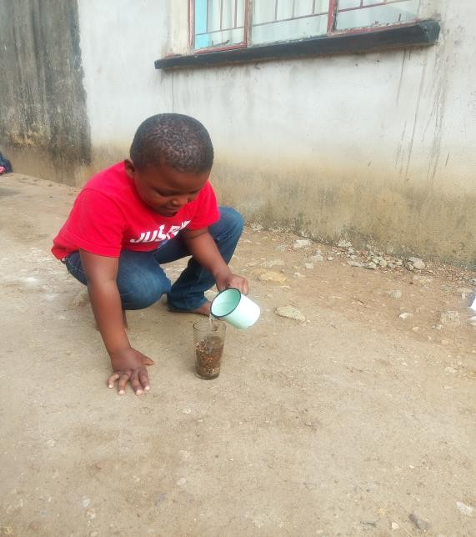

A clay soil. B sand soil. C silt. D humus

28 Which of the following types of soil is most suitable for farming? A loam soil. B clay soil C sand soil D silt

29. Which of the following is not an agent of weathering?

A wind B water C mineral water. D plant root 30 Water pollution maybe caused by

A drinking B sewage. C evaporation. D condensation 31 Which of the following is an example of organic fertilizer

A nitrogen B potassium. C manure D phosphorus 32 What is soil erosion?

A it is the adding of fertilizer to the soil B it is the washing away of top soil by wind or water. C.it is the way of looking at the particles of soil

D it is the arrangement of soil particles

1. When rubbed between fingers soil feels rough A sand. B. Gravel. C. Clay D loam
2. Plant nutrients are dissolved in. A Air B compost C. Water D fertilizer
3. Water conservation is the practice of A using clean water. B taking frequent showers. C using water wisely D using water consistently
4. Mud in the dam reduces. A The volume of water in the dam. B. Plant nutrients C. Air spaces D runoff
5. Study the diagram on the next page. What is possible plant x?

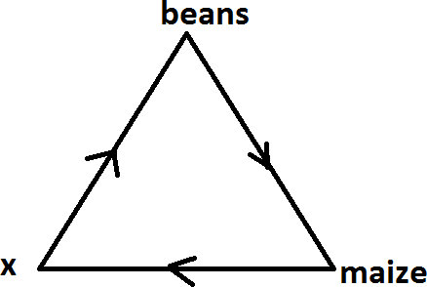

A Millet B sorghum C pepper D Rapoko

.38 Which of the following is an indigenous tree?

A wattle. B Gumtree. C musasa. D pine

39 Fruit vegetables are rich in

A calcium. B carbohydrates. C. proteins. D vitamins 40 Which one is a cereal crop?

A sugar beans B sorghum. C potatoes D tomatoes

41The name given to a seedbed is A a nursery B .a field C a garden. D an orchard 42 Which one is a field crop? A covo. B onion. C tomatoes. D sorghum

43 Which one is not a use of potassium? A helping plants to grow well B helping plants to resist frost. C Helping plants to produce high yields D helping to cause lodging.

44 suck sap from the plants A aphids. B earthworms. C early blight. D. eelworms

45 Maize is harvested when A the seed is at a hard dough stage. B we are in April. C they are affected by pests and disease D they are being stolen.

46 When is National Tree Planting Day celebrated in Zimbabwe? A When the effective rains fall. B First week of December. C first Saturday of December. D 25 of November

47 What is meant by planting in situ? A Transplanting seedlings to permanent beds. B Planting direct into a permanent bed without nursery. C Planting seeds without water. D Planting seeds where there is no soil

48 We grow fruit trees in A a field B a river. C an orchard D a woodlot

49. cutting down trees randomly is called A afforestation B deforestation C forestry D exotic planting

50 What is the role played by the root in plant growth?

A producing plant food. B it is a sexual reproductive organ C. storing food for plants. D. Allowing oxygen into leaves

##### EXAMINATION 1

**PAPER 2. (2 hours) SECTION A.**

There are six questions in this section. You are advised to spend not more than 75 minutes on this section.

1 . (a) Define the term agriculture. (1)

1. How is agriculture important at national level. (2)
2. Agriculture provide career opportunities. Who gives the farmer advice on his crop and livestock? (1)
3. What is a research in agriculture? (1)
4. (a) What is the difference between weather and climate? (2)
   1. How many farming regions do we have in Zimbabwe? (1)
   2. In which farming region is sugarcane grown under irrigation? (1)
   3. Why is it important for the farmer to study the weather patterns of his area? (1)
5. (a) Soil is made as a result of weathering. Weathered material from rock is mixed up with organic matter naturally. What is weathering? (1)
   1. Organic matter is made up of .........and........ (2)
   2. Give two types of weathering. (2) [Total 5]
6. (a) List the three major plant nutrients.(3)
   1. Suggest two ways of improving soil fertility. (2)
7. (a) Give two ways in which one can conserve moisture in the bed. (2)
   1. Give three examples of water pollutants. (3) [Total 5]
8. Copy and complete the table.

|  |  |  |
| --- | --- | --- |
| **ANIMAL** | **PRODUCT** | **BY-PRODUCT** |
| cattle |  |  |
|  | meat | Feathers to make cushions |
| rabbits |  |  |

**SECTION B.**

Answer any two questions. You are advised to spend not more than 45 minutes on this section.

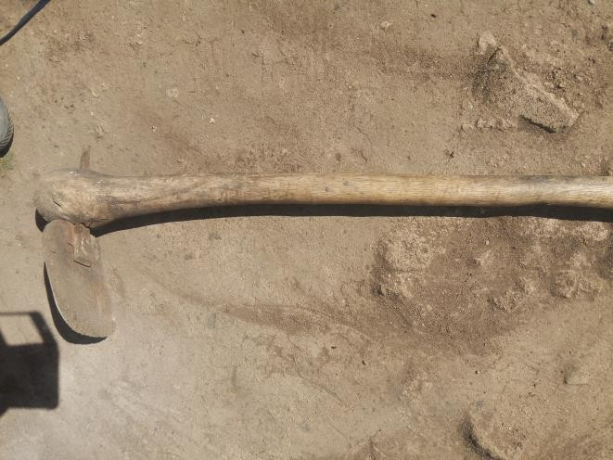

1. The diagram above shows a farm tool.
2. Name the tool. (1)
3. Give two uses of the tool. (2)
4. Which part need to be sharpened? (1)
5. Give two examples of each of each of the following tools.
   1. Diggging tool. (2)
   2. cutting tool (2)
   3. watering tool. (2) [Total 10]
6. The diagram shows parts of a plant.

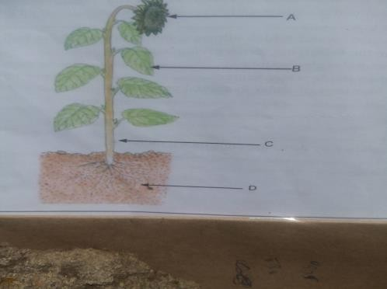

1. Name the parts labelled A-D. (4)
2. Give two functions of each of A, B, C and D. (6) [Total 10]
3. (a) Give three factors to consider when establishing an orchard. (3)
   1. Name any two
4. indigenous fruit trees. (2)
5. exotic fruit trees. (2)
   1. Give three processed products of fruits. (3) [TOTAL 10]
6. (a) Clearly explain how respiration is the reverse of photosynthesis. (2)
   1. What name is given to the branch of biology which deals with the natural process or activities of a living organism? (1)
   2. What is the function of chlorophyll on plants? (1)
   3. Explain in detail the process of
      1. photosynthesis
      2. respiration iii)transpiration iv)translocation. (4)
   4. Give two aids to pollination. (2)

EXAMINATION 2

**PAPER 1 (2 hours)**

ANSWER ALL QUESTIONS IN THIS PAPER.

1.Which of the following is provided by agriculture at school and at home A ploughing. B harvesting. C. weeding. D food

2 Choose a method for protecting plants from damage by cattle and goats

A digging ridges. B fencing field C creating fireguard. D building a shade 3 What is the best time to grow root vegetables in Zimbabwe?

A December to March. B September to December. C. February to April D March to September

4 A weed is A type of pest. B plant which grows it is not wanted. C type of chemical. D plant which provides nutrients to the soil

5 The housing system is mainly practiced in rural areas

A free range B deep litter C intensive D battery cage 6 A. is a housing system for chicks

A hutch B hay box brooder. C brooder. D battery cage

1. Which one is a transplanting tool?

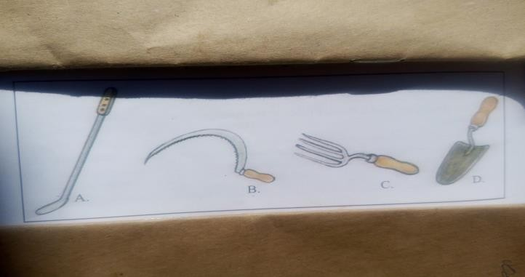

1. When should groundnuts be harvested?

A soon after germination. B when they develop flowers. C When mature D When the pods are soft

1. Why is it important to know the colour codes for pesticides? A so that chemicals can be sprayed. B To know how to dispose of agrochemicals. C To exercise caution. D so that one can burn containers.
2. A veterinary doctor is a

A Skilled worker B semi-skilled worker. C unskilled worker. D dangerous worker

1. Pesticides are used for controlling A weeds. B garden C pests. D fungi
2. Tools have.................Main parts. A one. B two C three. D four
3. What is a pick used for?

A carrying water. B. cutting trees and branch. C pruning hedges D Deep digging

1. Research in Agriculture helps. A develop good agriculture practices. B farmers to make huge losses C. Increasing pests, diseases and weeds. D in reducing profits of farmers.
2. Which one is not an importance of animals? A They are source of food. B They have cultural importance. C They are a symbol of wealth. D They cause soil erosion.
3. More often people view animals as A a sign of wealth. B a sign of poverty. C a sign of confusion. D a sign of laziness.
4. The following are common rabbits diseases except A coccidiosis. B fowl pox. C rye neck. D tapeworm.
5. The following are internal parasite except A mereki's disease. B round worm. C liver fluke. D tapeworm.
6. .......is used for harrowing. A Planter B Cultivator C Mould board plough D Harrow
7. Two implements used for harrowing are A disc harrow and spike toothed harrow. B planter and disc plough. C disc plough and disc harrow. D tractor and spike toothed harrow.
8. Farm machinery is important on a farm because A they increase yields. B they reduce yields C they increase weed output D they increase labor.
9. A Farmer noticed that friction is taking place on the axle of his Scotch cart. What should the farmer do? A Put grease on the axle. B Put water on the axle. C Put paraffin on the axle. D Put juice on the axle.
10. Tractor drawn implements should be operated by persons above the age of A 12 years. B 16 years. C 10 years. D 14 years.
11. Why are passengers not allowed on farm machinery? A They cause the driver to loose attention. B They push the driver. C They encourage the driver. D They discourage the driver.
12. Below is a picture of a mold board plough. Name the part labelled C. A shear B landslide. C frog. D handle.

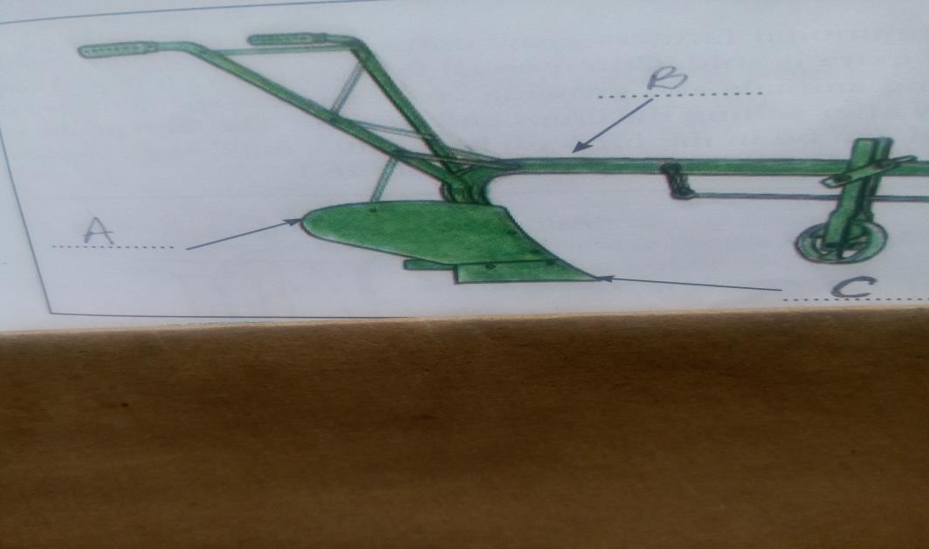

1. The shops that sell the final product to the consumers are called A big shops. B local shops. C retail shops. D national markets.
2. What are consumers? A People who buy products for sale. B Those who buy products for use. C People who sell products. D people who process agricultural products.
3. What name is given to crops grown and animals raised by farmers? A Agricultural products. B Farming inputs. C Agricultural markets. D Agricultural varieties.
4. Which of the following is an example of agricultural produce? A Clothes. B Dam. C Vegetables. D Gloves.
5. Where do most farmers sell their farm produce? A Local markets. B Mbare. C Overseas. D GMB.
6. What name is given to chemicals used to treat plants? A Agrochemicals. B Colour codes. C toxicity. D Dangerous chemicals.
7. Patience drank an agrochemical by mistake. What should she do? A Drink mazoe. B Visit the clinic as soon as possible. C Drink lacto. D Try to vomit.
8. How do farmers obtain money? By A stealing from others. B selling their products. C Working in other people's fields. D selling fertilisers.

34 are branches of agriculture. A Animal husbandry and crop production.

B Water and soil. C Food and clothes. D Vegetable and meat.

1. Which branch of agriculture deals with land use and government policy? A Agricultural Engineering. B Soil Science. C Agricultural Economics. D Crop Production.
2. Which one is an example of modern machinery? A Tractor. B Wooden hoe. C Stone axe. D Sledge.
3. The word which means our surroundings is A cultivated. B environment. C mankind. D wild plant.
4. Pick the one which is not an agricultural tool. A Garden fork B Pick. C Teaspoon. D Hand fork.
5. Which material is not used to make farm tools? A Plastic. B Wood. C Rubber. D Glass.
6. A machete is a ...........tool. A watering. B pruning. C cutting. D digging.
7. When using chemicals, it is important to A exercise extreme caution. B spray chemicals. C control diseases. D handle chemicals.
8. Which colour code means the most harmful chemical? A Green. B Orange. C Red. D Purple.
9. The type of work which can be done by an unskilled worker on a farm is A treating animals. B weeding. C telling forecasting on agricultural activities. D Recording wind direction.
10. Which of the following is not an aspect of weather? A Soil colour. B Temperature. C Cloud Cover. D Wind direction.

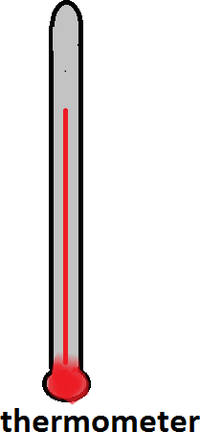

1. The instrument above is used to measure… A temperature. B humidity. C wind speed. D wind direction.
2. What are the dangers of using fire to clear the land? A Burns. B Cuts. C Poisoning. D Bruises.
3. Which is the proper place for keeping tools? A Bedroom. B Storeroom. C Fowl run. D kitchen.
4. Mixed farming is A growing crops from different families. B growing only one crop. C growing crops and keeping of animals. D growing cucumber
5. What determines the natural farming region in Zimbabwe? A rainfall. B wind. C humus. D amount of water vapor 50 Cattle farming is also known as

A herding B ranching c dairy. D beef

**EXAMINATION 2**

**PAPER 2 (2 hours) SECTION A**

There are six questions in this section. You are advised to spend not more than 75 minutes on this section.

1. (a) What term is used for the growing of crops and raising of animals? (1)
   1. State any three career opportunities found in agriculture. (3)
   2. Which branch of agriculture deals with the farm structures and construction of roads? (1) [Total 5]
2. (a) Give three advantages of organic manure. (3)
   1. How can a farmer conserve water in a vegetable bed? (2) [ Total 5]
3. (a) What is market gardening? (1)
   1. Give two branches of horticulture. (2)
   2. What is the difference between diversified and specialized farming? (2) [Total 5]
4. (a) What is water pollution? (1)
   1. Water can be polluted by......... and............. (2)
   2. State two man made sources of water. (2) [Total 5] 5.(a) Which tool can you use to remove stumps in a field? (1)

(b) How are tools grouped? (1)

(c Where do we safe keep tools? (1)

(d) Give any two ways of caring for tools. (2) [Total 5]

1. (a) What is a brooder? (1)
   1. State one by product we get from chicken. (1)
   2. Complete the diagram below with poultry diseases symptoms and control

|  |  |  |
| --- | --- | --- |
| **DISEASE** | **SYMPTOMS** | **CONTROL** |
| i. | Droppings with blood |  |
| ii. Fowl pox | Pimples on the head | Practice hygiene |
| iii. New castle |  | Isolate infected birds |

[Total 5]

SECTION B

**Answer any two questions. You are advised to spend not more than 45 minutes on this section.**

1. (a)Give two examples of each of the following tools:

1) digging tools

11)cutting tools

111) carrying tools. (6)

1. State three materials which can be used to make farm tools. (3)
2. Glass is not suitable for making farm tools. Why? (1) [ Total 10]
3. (a) Draw and label the water cycle. (7)
   1. How can you conserve water on a farm? (3) [Total 10]
4. Choose one fruit vegetable and describe how it is grown. Use the following headings.
5. Name of a crop. (1)
6. Land preparation and suitable soil. (2)
7. Planting. (2)
8. Correct spacing within and between rows. (2)
9. Harvesting. (2)
10. One diseases that attacks the crop. (1) [ Total 10]
11. Your class has been tasked to establish a woodlot.
12. Describe the factors which you would consider when choosing a site. (5)
13. Describe the care and maintenance of a woodlot. (5) [Total 10]

#### EXAMINATION 3

PAPER 1

**ANSWER ALL QUESTIONS IN THIS PAPER.**

1. One of the following is not a benefit of agriculture at national level

A food security. B employment. C foreign currency. D paying lobola

1. Three of the following are duties of an agronomist except A. research on crop diseases B. introduce new technology to boost production C. research on new crop varieties D. inform farmers on soil and climatic requirement for a crop
2. Who does the planning and budgeting on a farm

A. salesman B. mechanical engineer C. veterinary doctor D. farm manager

1. Name the tool used to plough large pieces of land A garden fork B spade. C ox plough D rake
2. Which of the following is suitable for digging moist soil? A mattock. B spade. C pick. D shovel
3. Is a traditional farming method A. treating seed with chemicals

B. treating seed with smoke C. spraying chemicals D. ploughing with a tractor

1. Which instrument is suitable for harvesting groundnuts?

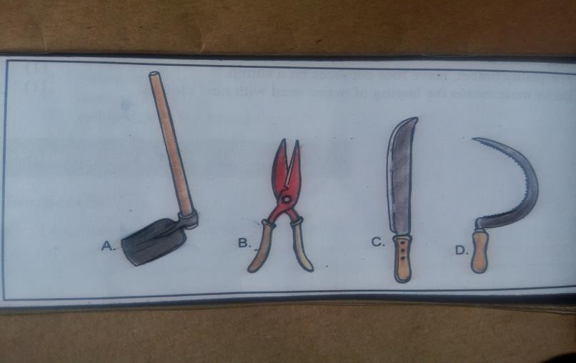

1. Which crop is a raw material for clothing industry? A sunflower B tobacco C cotton. D coffee
2. Tools are coated with oil so that they do not A rust B break C. wear fast D. harm workers
3. Who teaches our parents agriculture at home? A agriculture teacher. B lecturer. C Agritex officer D veterinary doctor
4. Farmers harvest their crops in. A summer B winter. C autumn D spring
5. The main activity under crop production is A growing crops. B irrigation. C keeping broilers. D training farmers.
6. Farmers in Zimbabwe sometimes get low maize yields because of A low temperate. B low rainfall. C high temperature. D high wind.

14 Summer has got. A 4 months. B 5 months. C 6 months. D 8 months.

1. Which part of the soil components is smallest? A mineral matter. B organic matter. C air. D water.
2. Conditions necessary for seed germination are A sunlight and water. B water and organic matter. C air, water and warmth. D air and organic matter.
3. How much rainfall is received in region 1? A Plenty. B Scarce. C Average. D None.
4. The percentage of air in the soil is A 10% B 13%. C 25% D 5%
5. Which one of the following is not a career in agriculture? A agronomist B Arex officer. C Driver. D Policeman.
6. Urea is an example of A compound fertilisers. B straight fertilisers. C phosphatic fertilisers. D potassic fertilisers.
7. The type of erosion which reduces soil depth uniformly is called A raindrops. B sheet. C gully. D rill.
8. A perennial river is a river which A gets dry during dry season. B flows throughout the year. C supplies water to a small home. D only supplies water to a school.
9. Which of the following is NOT an agent of biological weathering? A Plant root. B running water. C Animal hooves. D Man and his tools.
10. Tea and coffee is mainly grown in region A 2. B 1. C 4. D 5.
11. In which family do peas, beans and groundnuts belong? A Leaf crop. B Fibre crop. C legume crop. D root crop.
12. Which of the following is fibre crop? A Sugarcane. B sisal. C Beans. D Grass.
13. Name a nutrient that help to make plants green. A Nitrogen. B Potassium. C Copper. D Phosphorus.
14. Which one of the following is a list of cash crops? A beans, maize, tobacco. B tobacco, cotton, tea. C maize, cotton, tea. D beans, tobacco, cotton.
15. What is grown in an orchard? A Cash crops. B Vegetable crops. C Fruit trees. D tree crops.
16. Which one of the following is not a Brassica? A Cabbage. B Spinach. C Kale. D Tsunga.
17. ............. is a climate requirement for Brassica. A Wet soil B Cool to warm temperature C Well drained soil D Hot weather
18. Which one is not a vegetable crop? A Rape. B Maize. C Tomato. D Carrot.
19. Choose a leaf vegetable from the list. A Covo. B Tomato. C Beans. D eggplant.
20. Which of the following list of crops is staple diet in Zimbabwe? A groundnuts, maize, sorghum. B maize, wheat, sorghum C wheat, tobacco, cotton. D beans, groundnuts, sorghum.
21. Which crop is rich in proteins? A Maize. B Soya beans. C Sorghum. D Wheat.
22. Select a nutrient which encourages development of roots in plants. A Potassium. B Nitrogen. C Phosphorus. D Hydrogen.
23. Which of the following is NOT true about trees? A Give us oxygen. B Give us meat. C Give us medicine. D Control erosion.
24. Putting grass on the basin around the tree is called A watering. B manuring. C mulching. D shading.
25. Mulching is done to A conserve moisture. B provide warmth. C provide a good bed. D provide manure
26. What type of irrigation is shown?

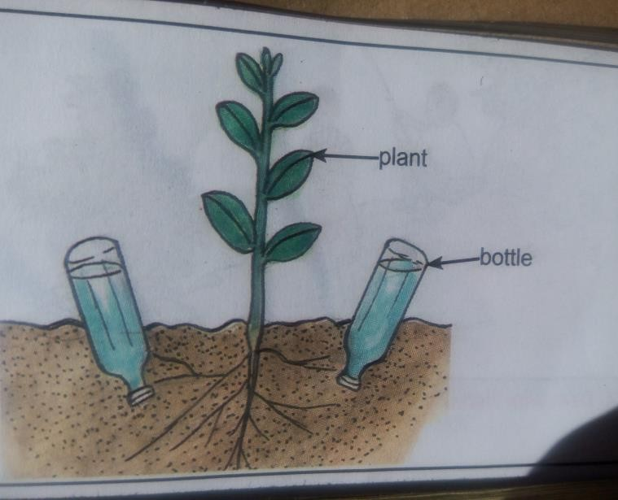

A Drip. B Flood. C Overhead. D Pitcher.

1. Which one of the following is not suitable for making a compost? A Maize stalk B wheat straws. C used plastics. D manure.
2. Select a reason for making a compost. A To reduce soil moisture. B Increase manure. C Prevent frost. D Avoid use of fertilisers.
3. Trees from other countries are called A indigenous. B gums. C wattle. D exotic.
4. The kind of a tree chosen for a woodlot should be A resistant to borers. B Resistant to termites. C fairly quick growing. D hard to burn.
5. An example of pest that is troublesome in nurseries is A termite B rat. C bacteria. D bird.
6. Soil moisture returns to the atmosphere through the process called A evaporation. B infiltration. C respiration. D transpiration.
7. Name a crop which is out of place. A Groundnuts. B Sorghum. C Lucerne. D Beans.
8. How many times would tomatoes be watered per week? A Once. B Twice. C Three times D Four times.
9. Supporting tomato plants is called A spacing. B mulching. C stalking. D weeding.
10. Select the part which supports a tree. A Stem. B Leaves. C Roots. D Flowers.

##### EXAMINATION 3

**PAPER 2 (2 hours) SECTION A**

There are six questions in this section. You are advised to spend not more than 75 minutes on this section

1. (a) What do we mean when we say, agriculture is the backbone of the nation? (1)
   1. Name any three branches of agriculture. (3)
   2. Which branch deals with cattle ranching? (1) (Total 5) 2 (a) Explain the following terms.
      1. skilled worker.
      2. semi skilled worker.
      3. unskilled worker. (3)
2. Give one reason why research is important to agriculture. (1)
3. Why do farmers employ people? (1)
4. (a) Name two major climatic conditions which makes it possible to classify areas into natural farming regions. (2)

(b) study the diagrams on the next page and answer the questions which follow

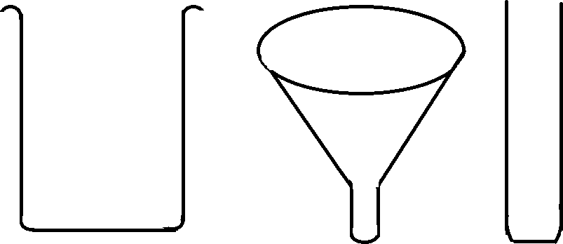

* 1. Name instrument above. (1)
  2. What does the instrument measure?

(c) Barometer is used to measure…………… (1) (Total 5)

1. (a) State any three reasons for ploughing the land. (3)

(b) Write two farming activities which can be done by a planter. (2) (Total 5) 5.(a) Why is a farm workshop useful? (2)

(b) When is a harrow used? (1)

(c) Name two maintenance tools. (2)

1. (a) What are the benefits of crop rotation to a farmer and the soil? (2)
   1. What do you understand by the phrase 'fertilizer banding'? (1)
   2. In crop rotation, what do you understand by the term 'ley'?

SECTION B

Answer any two questions. You are advised to spend not more than 45 minutes on this section

1. Choose one leaf vegetable and describe how it is grown. Use the following headings.
2. name of the crop.(1)
3. land preparation. (2)
4. planting. ((2)
5. spacing. (2)
6. harvesting. (2)
7. give common disease that attack the crop. (1)
8. You want to plant a Brassica.
9. Explain seedbed preparation. (5)
10. How would you plant a Brassica seed? (5)
11. Explain how a legume vegetable crop is grown under the following headings.
12. variety (1)
13. land preparation.
14. planting.
15. Described the management of a root vegetable crop using the following:
16. Weeding and disease control. (5)
17. Fertilizer application. (3)
18. Earthing up. (2)

**EXAMINATION 4**

**PAPER 1 (2 hours)**

**ANSWER ALL QUESTIONS IN THIS PAPER.**

1. A farmer who grows crops just to feed his family is practising

A monoculture. B subsistence farming. C mixed farming. D extensive farming.

1. The common value of animals is that they all A provide milk. B provide eggs C provide meat. D have skins and hides

3 A cash crop is. A a crop sold for cash only B a crop bought for cash only. C a crop grown for sale only. D a crop grown for those with cash only

4............is an agriculture produce. A manure B fertilizer C milk. D chemicals 5 The part that is eaten from a legume vegetable is the A fruit. B pod. C root.

D bulb

1. Seasons change due to. A rainfall and temperature. B soil type C amount and size of mountains D rivers and dams of an area
2. Choose the function of soil water. A washing the plants. B watering the plants. C dissolving nutrients in the soil D absorb nutrients from the soil
3. The type of erosion which carries soil particles away and causes small channels to form is. A rill. B sheet. C gully. D none of the above
4. Which one of the following is out of place? A mulching. B cover crops. C weeding. D cultivation
5. Select a method of moisture conservation A field crops. B. Harvesting. C flood irrigation. D cover crops
6. What comes out when water is boiled? A hot water. B warm air C. Water vapor. D heat
7. An underground source of water is. A tap. B river C lake. D spring
8. Choose a function of leaves from the list below. Leaves……. A. anchor the plant. B absorb nutrients. C manufacture food for the plant. D transport food up the plant
9. Choose a function of roots from the list below. A storing food for the plant. B manufacturing food for the plant. C transpiration D photosynthesis

15. A major cause of water pollution in town is. A drinking. B transpiration. C sewage. D photosynthesis.

1. The following animals promote tourism except A buffalo. B sheep. C lion. D kudu
2. The following are importance of wild animals except A ivory. B tourism. C. hunting D milk production
3. Fodder crops are grown for. A feeding human beings. B improving soil fertility. C feeding livestock D controlling erosion
4. How far apart should tomato plants be spaced. A 30cm. B 35cm. C 40cm D 45cm 20The right time to transplant tomato seedlings is when the weather is A cold.

B cloudy. C. Hot. D windy

1. Select the part that carries water up the plant A flowers. B stem. C branch. D leaves
2. Which one is not a use of trees? A cooking. B furniture making C paper manufacturer D stone carving
3. When growing field beans, which fertilizer do you apply at planting? A ammonium nitrate. B urea. C compound D D compound S
4. What is the spacing between rows of field beans when planting. A 30cm. B 45 cm.

C. 90 cm. D 1-5cm

1. A..........is used for breaking the soil into smaller particles using a span of oxen. A. mould board plough. B garden. C. Cultivator. D harrow
2. Growing trees is called A afforestation. B deforestation. C. Leaching. D erosion
3. Which of the following is not an effect of weeds? A reduce yield. B reduce quality. C improves the yield D reduce growth
4. Fire spreads fast when it is A raining. B windy. C misty. D cold
5. Removal of seedlings from pockets to individual containers is called A transferring. B pricking out. C transplanting. D planting
6. What class of crops does maize belong to? A cereal. B legume. C root. D fruit
7. One of the nutrients which should be applied at planting is. A carbon. B phosphorus. C nitrogen. D calcium
8. One tonne is.............kg A100 B 1000 C 10 000 D 100 000

33. The following are local markets except. A bank. B school. Shopping Centre D bus stop

1. The following are uses of the garden hoe except A digging. B weeding. C. Levelling. D harvesting
2. Zimbabwe has........seasons. A four B three. C. two D five
3. A pest which eats maize leaves is A red spider mite. B cutworms. C maize stalk borer. D armyworm
4. A fruit grown from suckers is A guava. B mango. C banana D orange
5. The kind of tree which can produce straight poles in a woodlot is the. A Gumtree.

B. Musasa tree. C baobab tree. D none of the above

1. In Zimbabwe, a lot of cattle is a sign of A status. Business. C wealth. D poverty.
2. Keeping few animals on a large piece of land, allowing them to look for their own food is A semi-intensive system B an extensive system. C an intensive system D a mixed system
3. If someone is growing crops and keeping animals for selling, this is A agro business. B mixed business. C single business. D double business
4. People hired to weed maize, pick tobacco, dehusk maize, and pick groundnuts are referred to as. A weeders. B unskilled workers. C skilled workers. D semi - skilled workers
5. Why are exotic tree woodlot is preferred to those indigenous trees? A they originated from other countries. B they are fast growers. C they withstand long dry periods D people do not just need indigenous trees
6. Which of the following is a source of carbohydrates? A soya beans. B sunflower. C groundnuts. D maize
7. Agriculture is important to the family except for. A attracting tourists B creating self -employment C providing food. D generating income
8. Which season best suits maize planting? A summer. B winter. C spring. D Automn
9. At what age are broiler chicks transferred to the deep litter house? A 4 weeks. B 6 weeks. C 8 weeks D10 weeks
10. What is manure from rabbit dropping called A organic matter. B artificial manure. C commercial manure. D livestock litter
11. Rabbit are kept in a………. A brooder. B kraal. C fowl run. D cage
12. The courseness or fineness of the soil is called A pH. B structure. C profile. D texture.

EXAMINATION 4

**PAPER 2 (2 hours) SECTION A**

There are six questions in this section. You are advised to spend not more than 75 minutes on this section

1. (a) Define the following terms:
   1. mixed farming
   2. monoculture
   3. diversified farming. (3)

(b) List two advantages of mixed farming. (2)

(Total 5)

1. (a) What name is given to the farming of vegetables and flowers? (1)
2. Briefly explain why dairy farming is located close to the urban areas. (2)
3. Give two career opportunities found in agriculture. (2)

( Total 5)

1. (a) What is a budget? (1)
2. Why is a budget important on a farm enterprise? (2)
3. Calculate the income obtained from a vegetable Enterprise when it made a profit of $118 after spending $400. (2)

( Total 5)

1. (a) A farmer produced rabbits at a cost of $230. About $420 was obtained from the sale of rabbits. How much profit did the farmer obtain from keeping rabbits? (2)

(b)List the items for preparing a budget for a vegetable enterprise. (3)

(Total 5)

1. Explain five ways of maintaining farm implements and machinery. (5)

( Total 5)

1. (a) From which crop do we get the following products:
   1. ethanol
   2. cooking oil. (2)
2. Write down any one branch of agriculture. (1)
3. Write down two activities done in (b) above. (2) (Total 5)

**SECTION B**

**Answer any two questions. You are advised to spend not more than 45 minutes on this section.**

1. (a) Describe the work of the following people:
   1. agriculture engineers
   2. agronomists. (2)
2. List two roles of:
   1. soil water. (2)
   2. soil living organisms. (2)
3. Why is humus important to the soil? (3)
4. Which soil sticks when wet? (1)

[Total 10]

1. (a) The three enemies for crops are................and....... (3) (b)Name two common pests for beans. (2)
2. Name two ways you would use to control wild animals in your field. (2)
3. Name any three cash crops in Zimbabwe. (3)

[Total 10]

1. Below is an income and expenditure table.

|  |  |  |  |  |  |
| --- | --- | --- | --- | --- | --- |
| **DATE** | **EXPENDITURE** | **VALUE** | **DATE** | **INCOME** | **VALUE** |
| 17/04/16 | 100 day old chicks | $85 |  |  |  |
| 17/04/16 | 2 by 50kg starter at $33 each | i)  $............. |  |  |  |
|  |  |  | 12/05/16 | 15 bags manure at  $1 a bag | v)$.........  ........... |
| 21/05/16 | 5 by 50kg finisher pellets | ii)  $................ |  |  |  |
| 28/05/16 | 200g E.S.B at $8 per log | iii)  $................ | 04/06/16 | 90 birds at  $7 each | $630 |
|  | TOTAL | iv $................ |  | TOTAL |  |

1. Complete the table. (6)
2. Calculate the profit or loss. (2)
3. name any other two farm records you have learnt. (2)

[ Total 10]

1. (a) State three disadvantages of extensive system of rearing chickens. (3)
2. State three advantages of intensive system of rearing chickens. (3)
3. Name two diseases for each type of animal:
   1. chickens. (2)
   2. Rabbits. (2)

[Total 10]

. EXAMINATION 5

**PAPPER 1 (2 hours)**

ANSWER ALL QUESTIONS IN THIS PAPER.

1Agriculture is the .

A growing of crops. B keeping of animals. C repairing farm machinery D growing of crops and keeping of animals.

2 In shifting cultivation farmers use as fertilizer A manure. B compound D C ash. D ammonium nitrate 3 What is found as a bedding on the floor of a deep litter house? A litter. B wire mesh. C feed troughs. D stock feeds

1. Select a commercial rabbit feed from the following

A wondering. B Lucerne. C vegetable leaves. D rabbit pellets 5 Which one is the main use of cattle in rural areas?

A provide draught power. B show displays. C lobola. D none of the above

6 When feeding animals we should give them

A water only. B food only C both water and food. D soil water 7 The following are animal products except

A meat. B milk. C eggs. D fruits

1. is not an animal by product A milk. B butter. C eggs. D meat 9A young one of a chicken is called.

A grower. B hen. C cock. D chick

10 The structure used to provide heat to young ones of. Chickens is called A fowl run. B brooder. C nest box. D cage

11 Choose a poisonous food that should not be fed to rabbits from the list below A tomato leaves. B Lucerne. C pellets. D hay

12 When feeding animals with dry feed you should give.

A more water. B less water. C no water. D none of the above 13 Which statement is not correct

about farm equipment and machinery?

A They make work easier

B They increase farm produce

C Work is done on time

D They are always available to the farmer

14 Which process does not use farm equipment and machinery? A harrowing B ploughing. C germination. D spraying 15 Which produce is sold/marketed by colcom

A beef. B bacon. C cotton. D fruits

16 CSC stands for . A cotton selling company. B Central selling company C Common selling company D Cold storage company

17 When is profit made in business?

A when income is more than expenditure

B When expenditure is more than income

C When expenditure is the same income

D none of the above

18 What does Zimbabwe benefit from exporting farm products like eggs, beef and tobacco?

A employment. B qualified manpower C foreign currency. D income

19. Which branch of agriculture would use the equipment shown on the picture?

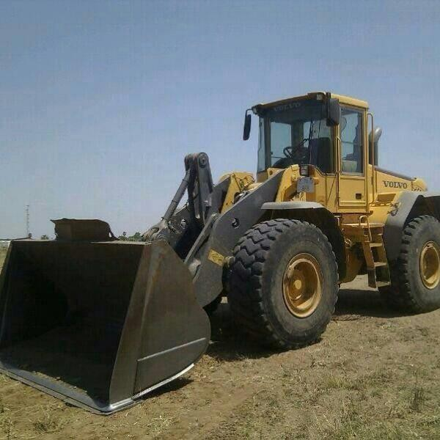

A Agricultural engineering. B Agricultural Economics. C Soil Science. D Crop production.

1. How do animals cause soil erosion?

A by drinking too much water. B. By making too much noise. C by loosening the soil with their feet as they walk. D by dropping their waste everywhere.

1. Which of the following minerals is needed for bone formation? A calcium. B phosphorus. C copper D magnesium
2. Which of the following is not a nutrient?

A carbon. C proteins. C minerals. D chlorophyll

1. What should you do to make sure that your hoe weeds well?

A wash after use. B water soil C replace handle. D sharpen

1. Which of the following crops brings in most foreign currency to Zimbabwe? A vegetables. B fruits. C maize D tobacco
2. A farming system which provides more employment opportunities is.

A shifting cultivation. B large scale commercial farming C home gardening. D subsistence farming

1. Which of the following is not a type of farming?

A monoculture. B intercropping. C shifting cultivation D mixed farming 27 Which one of the following statements is true?

A ploughing is done after planting seed

B weeding is not an agricultural activity

C Planting seed is done after ploughing

D A slasher is used for digging and weeding

1. Wheat, barley and oats are crops A winter. B summer. C autumn. D spring
2. Seasons are determined by.

A climate and soil. B humidity and wind. C rainfall and temperature D humidity and rainfall

1. Rains for the summer seasons usually starts in

A early January. B mid May. C June. D November

1. Which one of the following crops is affected by very low temperature? A peas. B onions. C tomatoes D cabbages
2. A machine used to harvest crops on a large scale is a A disc plough. B combine harvester. C tractor. D lawn mower

33What type of farming is mainly practised in Region 5?

A intensive. B semi intensive. C extensive. D specialised 34 Which city is in region 2

A Bulawayo B Gweru C Harare. D Mutare 35 Which one is a use of soil mineral?

A supply plant with nutrients B supply oxygen. C supply organic matter. D supply water

1. Inorganic matter has.

A 25%. B 5% C 45%. D 90%

1. Which soil type has the largest particles?

A loam. B clay. C sand. D sand loam

1. The danger of working on top of the compost heap is. A fear of snakes. B fear of falling down. C that it will drive out air needed for decaying D that you maybe affected by diseases

39. A is a man-made source of water A borehole. B spring. C rain. D river

40 is not a method of harvesting water

A dam construction. B building a weir. C drilling a borehole. D treating water with chemicals

41. A person who supervises the day to day running of a farm is a.

A Research technicians technician

B teacher. C farm manager. D veterinary officer 42 Which of the following is not organic matter?

A tree leaves. B dead animals. C grasses. D stones

42 One of the following factors contributes to the loss of soil nutrients A erosion. B weathering. C manuring D weeding

43 Name the part of the plant which absorbs nutrients from the soil

A leaves. B roots. C bark. D stern

44 An example of an element which is used to produce fertiliser with one neutrient is A calcium. B copper. C phosphorus. D carbon

45 Which one of the following equipment should be cleaned to prevent blockage? A shears. B sprayer. C sickle D hosepipe

246The height of a compost heap should be A 1,2m B 2,0m. C 2,5m. D 3,0m

47 Dust in the air is a sign of

A air erosion. B wind erosion. C water erosion. D danger erosion 48 Which of the following is not an example of weathering?

A oxygen B running water C freezing water. D temperature

49 A tool used for lifting seedlings during transplanting is a. A dibber. B garden trowel. C how. D watering can

50 Cultivated plants are grown in the following places except. A orchard. B garden. C field. D. Forest

EXAMINATION 5

**PAPER 2 (2 hours) SECTION A**

There are six questions in this section. You are advised to spend not more than 75 minutes on this section.

1. List five equipment you will store in the tool shed. (5)
2. (a) What happens when tools are left in the rain? (1)
   1. State a technique of identifying tools. (1)
   2. How do you avoid the mixing of tools in the storeroom? (1)
   3. State two safety precautions you would observe when using hoes. (2)

[Total 5]

1. Copy and complete.

|  |  |  |
| --- | --- | --- |
| **NATURAL FARMING REGION** | **RAINFALL** | **ACTIVITIES** |
| Region 1 | a) | b) |
| Region 2 | c) | d) |
| e) Region | Less than 500mm | Irrigation of sugarcane and citrus fruit trees |

1. (a) Give two advantages of wind in agriculture. (2)
   1. Give the units for measuring
      1. temperature.
      2. rainfall.
      3. air pressure. (3)

[Total 5]

1. (a) State any three agents of Environmental Management Agents. (2)
   1. Name three agents of physical weathering. (3)
2. (a) Name three types of erosion. (3)
   1. Name two agents of soil erosion. (2)

SECTION B

Answer any two questions. You are advised to spend not more than 45 minutes on this section.

1. (a) Soil component a=25%, b=25%, c=45% and d=5%. Which components are labelled a to d? (4)
   1. Draw a plant and label all the main parts. (4)
   2. State any one function for any two parts labelled above. (2)

[Total 10]

1. (a) What are the disadvantages of silt in the soil? (2)
   1. What is algae?
   2. How is water polluted by certain industries? (3)
   3. State two disadvantages of flood irrigation. (2)
   4. How can you conserve water in seedbed? (1)

[Total 10]

1. (a) State three reasons why a budget is important. (3)
   1. State two aspects of caring for tools. (2)
   2. Name any five tools used on a farm. (5)

[ Total 10]

1. (a) Which animals form the big five under Wild Life Management? (5)
   1. How are plants and animals protected from fire? (2)
   2. How best can you protect plants from drought. (2)
   3. The best method of propagating sugarcane is by use of. (1)

EXAMINATION 6

**PAPER 1 (2 hours)**

ANSWER ALL QUESTIONS IN THIS PAPER.

1. In Agriculture, workers such as security guards and cattle herders and those who weed manually are referred to as......... Workers. skilled B semi skilled C unskilled D professional
2. What type of soil erosion is demonstrated on the picture?

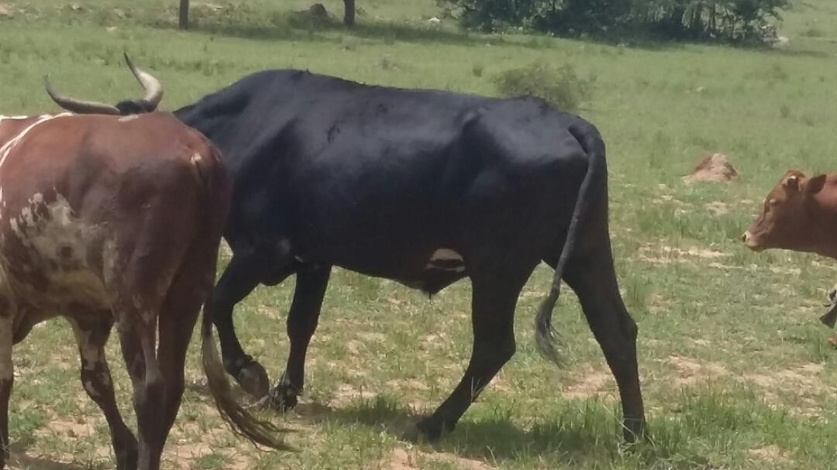

A Physical erosion. B Biological erosion. C Chemical erosion. D Sheet erosion. 3 What will happen if a maize crop is harvested with high moisture content?

A it will dry quickly. B it will rot. C it will become moisturised. D yields will be high 4 Sugarcane grown in Chisumbanje is also used to produce

A petrol. B ethanol. C diesel. D paraffin

1. Which one is an example of an annual crop? A peas. B carrots. C onions. D wheat
2. Which one of the following plants does not belong to the cereal family? A maize. B peas. C sorghum. D millet
3. Animals are an important source of food. They are rich in A carbohydrates. B vitamins. C proteins. D minerals
4. Overgrazing may cause. A paddocks. B soil erosion. C soil conservation. D mulching
5. What is the advantage of mulching? A it reduces the rate of moisture evaporation

B it allows breeding of pests

C it creates competition for sunlight

D There is a lot of grass in the environment

1. Which type of green feeds is poisonous to rabbits? A cabbage. B grass. C lettuce. D potatoes
2. What is gestation period for rabbits? A 19 days. B. 28 days. C 41days D 42days
3. The housing system for rabbits is called A hutch. B brooder. C battery cage. D free
4. The branch of agriculture responsible for breeding and management of animals is A crop production. B animal husbandry. C agriculture economics. D agriculture engineering

14. The learners on the picture discovered that their newly planted seedlings were wilting. Which plant requirement was lacking?

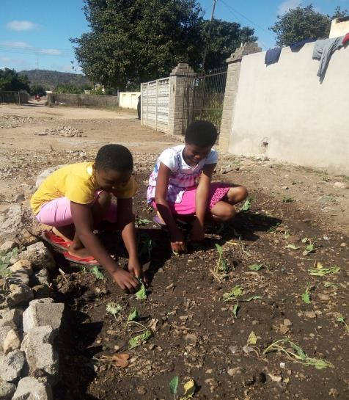

A Water. B Air. C Nitrogen. D Sunlight.

15 What name is given to chemicals used to treat plants A agrochemical B colour codes. C toxicity. D dangerous chemicals

16 A hoe is used for A watering. B cutting grass. C pruning hedges. D digging and weeding

17What should be done to stop a hoe from slipping off your hands? A put oil on the handle. B sharpen the hoe C the cutting edge should face down. D hold it firmly

18 The triangle on a pesticide is a sign

A warning. B decorative. C recycle. D disposable

19. If maize, sunflowers and beans are grown in the same field, at the same time, this type of farming is called A rotation. B inter cropping. C monoculture. D winter plough

1. Which of the following is a career opportunity in agriculture? A medical doctor. B veterinary surgeon C guard D nursing
2. Skin contact with chemicals can cause A chicken pox. B skin rush. C cuts. D measles
3. Which of the following is a safety precaution when storing chemicals? A never store pesticides with food stuffs

B Read the label and understand all instructions

C Wear protective clothing before using chemicals

D avoid equipment accidents when storing chemicals

1. Rivers are usually flooded in A summer. B autumn. C winter. D spring
2. Which of the following agricultural activities is practised in natural region 1? A growing of wheat, soya beans and tobacco B fruit and plantation forestry C livestock and irrigated crops D extensive cattle and game ranching
3. Which one is not an element of weather A wind speed. B thermometer. C rainfall. D temperature
4. Generally high attitude places are A very hot B cooler. C very dry. D very warm
5. How does a farmer protect his or her farm against veld fires? A By doing irrigation. B by doing horticulture. C by preparing a fire guard D by planting many trees

28The process by which soil is formed is . A erosion B composition. C weathering D organism

29 What is transpiration? A It is the falling of plants when it is hot

B it is the loss of water from plants through the leaves

C It is the wilting of plants when it is cold

D It is the loss of water from the soil

30Which of the following is a major factor affecting agriculture in Zimbabwe? A rainfall. B soil. C temperature D vegetation

31 The work of keeping something in good condition is called

A inventory. B maintenance. C precaution. D recording 32What should we do when using chemicals?

A exercise extreme caution. B control disease. C control sprays. D handle chemicals 33 Chemical weathering is caused by

A temperature. B plant roots. C small animals. D chemical reactions 34 Biological weathering is caused by

A moving air. B living things. C chemical reactions. D moving water 35 Which is the best type of soil for crop production?

A loam. B clay. C sand. D silt

36 A. is a plant whose roots fix nitrogen in the soil. A Grain. B vegetable. C legume. D fruit 37 The way soil particles are held together is soil.

A texture. B profile C formation. D structure

1. Which soil component improves water content of the soil?

A mineral water. B air. C organic matter. D living organisms

1. Clay soil has. particles. A smooth. B smooth and gritty C smooth and rough. D rough or gritty
2. A fully developed soil profile consists of the following layers subsoil, parent rock, and. A top soil and subsoil. B parent rock and gravel. C top soil and ground. D parent rock and sub soil
3. Which of the following is a method of recycling water? A allowing water to drain. from the sink. B watering the garden using water that was used to clean the fruits. C cleaning a vehicle using fresh water. D taking a bath using a bucket
4. is an agent of weathering. A heat. B a stone. C a leaf. D fire
5. Rock particles mix with decaying plant and animal matter to make. A soil. B compost. C litter. D humans
6. aids the germination of seeds

A water. B topsoil. C organic matter. D mineral matter 45 Air consists of nitrogen, carbon dioxide and.

A water. B mineral matter. C oxygen. D air

1. The largest water storage reservoir in the water cycle are. A clouds. B dams C lakes. D oceans
2. The dam built in Zimbabwe mainly to supply water for irrigating sugar cane is A Chivero. B Kariba. C Mutirikwi. D Manyame
3. Which is not an importance of living organisms in the soil?

A They release nutrients from decomposition of organic matter

B They degrade harmful chemicals

C They leach nutrients by drainage

D They aerate soil through burrowing

1. Which one of the following is a disadvantage of inorganic fertilizers? A They are cheap. B they make plants grow well

C they are expensive. D they are easy to carry

1. An example of perennial crop is A maize. B wheat. C sugarcane. D beans.

EXAMINATION 6

**PAPER 2 (2 hours) SECTION A**

There are six questions in this section. You are advised to spend not more than 75 minutes on this section.

1. (a) State two importance of farming to the country. (2)
   1. List two important careers in agriculture. (2)
   2. Explain why one of the careers you listed above is important. (1)

[Total 5]

1. (a) List two things other than food that are provided by agriculture. (2)
   1. Give two companies in Zimbabwe that process agricultural produce. (2)
   2. What do farmers get from selling their products to other countries? (1)

[Total 5]

1. (a) List three man made sources of water you have learnt. (3)
   1. Write down any two uses of water in agriculture. (2)

[Total 5]

1. (a) Give three uses of plants in agriculture. (3)
   1. Name two tools used for digging. (2)

[Total 5]

1. (a) The condition of atmosphere at any given time is called. (1)
   1. List two elements of weather and the tools used to measure them. (4)

[ Total 5]

1. (a) Suggest human activities that may cause climate change. (3)
   1. List two effects of climate change to agriculture. (2) [Total 5]

**SECTION B**

Answer any two questions. You are advised to spend not more than 45 minutes on this section.

1. describe the processing and marketing of products and by-products from either rabbit or poultry. [10]
2. You have visited a commercial farm on educational tour. (a) Name five implements used by farmers. (5)
   1. State three ways farmers use to control diseases and pests in the field. (3)
   2. Explain how farmers can protect crops from the following:

(i) drought (ii)animals. (2)

[Total 10]

1. (a) Discuss the making of a compost heap using the following headings:
2. materials used in making a compost heap. (3)
3. tools needed (2)
4. measurement of a compost heap. (2)
5. List two types of organic matter. (2)
6. Why is air needed in a compost heap? (1) [ Total 10]
7. (a) Describe how you would prepare the land to grow flowers in situ. (4)
   1. List two varieties of flowers grown from (i) seeds.

(ii) tubers. (4)

(C) List two pests that affects flowers. (2) [total 10]

EXAMINATION 7

**PAPER 1 (2 hours)**

ANSWER ALL QUESTIONS IN THIS PAPER.

1. In which career are people employed indirectly by agriculture?

A farm manager. B mechanics. C veterinary doctor. D lecturer

1. Food that feeds people in town comes from - A miners. B farmers. C drivers. D pilot
2. Why is soil conservation important?

A it manages water for irrigation. B it removes soil cover. C it is ploughing across the slope. D it prevents soil erosion

1. A sign of moisture stress in plant is.

A green leaves. B stunted growth. C dry soil. D wilting 5 When water cools and forms droplets, that stage is called.

A transpiration. B respiration C evaporation. D condensation

1. Earthworms, beetles and bacteria help to improve the soil. A colour. B size. C texture. D structure
2. is a legume crop. A maize. B groundnuts. C sorghum. D mango 8Which one is a function of leaves

A storing water B producing plant food. C Give nitrogen to roots. D Allowing fertilisers to the soil

1. Temperature changes cause rocks to

A expand and contract. B become harder. C become smaller. D have layers

1. Aquifers are. A underground streams. B seas and oceans. C country dams. D natural water tables
2. The most common organic fertilizer used in Zimbabwe is from.

A excretion of cattle. B component z C dead plants. D limestone

1. Land should be terraced to. A remove large gullies. B maintain grass cover. C cut steep slopes. D remove ground cover
2. The main purpose of soil cultivation is

A to loosen the soil. B to destroy weeds. C to show their riches. D to improve the life of organisms

1. The picture shows an orange tree it is a tree

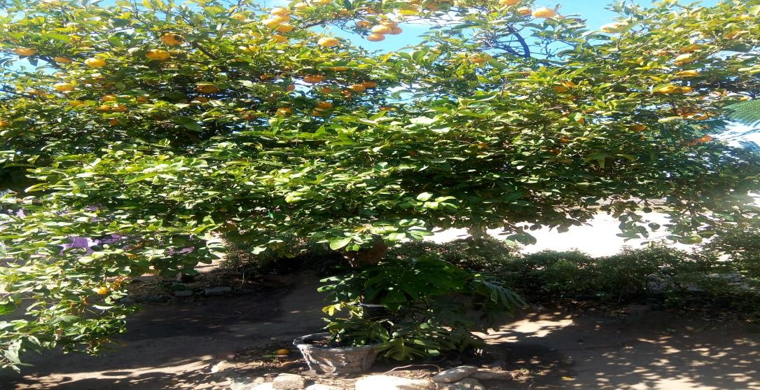

A citrus. B indigenous. C common. D rare. 15 Root vegetables do well in which type of soil?

A rocky soils. B sand loam soil. C shallow soil D clay soil

1. Water that flows on the land is called?

A rain drops. B water logged. C runoff D rain gauge

1. Which part of the plant produce seeds?

A roots. B water logged. C flowers. D stem

18 Trees release water vapour into the atmosphere through.

A condensation. B evaporation C infiltration. D transpiration

19. Which of these is a soil pollutant?

A dust B muddy water. C acid rain. D irrigation water 20 Which plants are propagated by cuttings?

A mango and pawpaw. B avocado and guava. C mulberry and sugarcane D guava and sugarcane

21 The practice of taking care of land to protect it from damage is called soil. A erosion. B pollution. C profile. D conservation

22 Which fertilizer is used to help tomato plants grow well?

A compound. B ammonium nitrate C potassium. D phosphate 23 Which of the following is not a cause of deforestation?

A too many people living in an area B planting sisal C clearing land for Crops D fencing garden with branches

24 Raindrops erosion is also called. A gully. B splash. C sheet. D rill

25What name is given to plants that gives us a lot of starch? A fibres. B cereals. C oils. D coconut

26 What do we call the period from seed germination through growth to maturity of plants? A life cycle. B long life. C good life D bad life

27 What name is given to the department of agriculture that supports paper making industries? A Agronomy. B Horticulture. C wildlife management. D forestry

28 Farming which involves maximum use of land to produce crops and animals

A intensive farming. B diversified farming C mixed farming. D shifting farming 29The filling up of dams and river beds with topsoil is called

A siltation. B evaporation. C erosion. D weathering

30 A supply of oxygen is necessary in the soil for respiration of roots and some soil

A organisms B agents. C crumbs. D particles

31 A soil a balanced mixture of particle sizes , a good humus content and stable crumb structure is called. A gravel. B sand. C clay. D loam

32 Which tree grows from shoots A mukwa. B gum. C teak. D bloodwood

33. The estimate of income and expenditure is called A profit. B budget. C loss. D account

34 What is the correct spacing between rows for groundnuts is.

A 10cm. to 45cm. B 5cm to 10 cm C 0cm to 15cm. D5cm to 10cm

35. Spacing from one plant to another for groundnuts is. A 10cm to 45cm B 5cm to 10 cm. C o cm to 15cm. D 7,5cm to 15cm

36When the soil remains unprotected for a long time, rill erosion will develop into A sheet erosion. B splash erosion C gully erosion. D raindrops erosion

1. Maize should be top dressed using.

A urea or ammonium nitrate. B compound D. C compound X. D compost manure

1. When you check for pests in a field, this is called A checking. B scouting. C managing. D pesting
2. Transfer of pollen grains from male to female parts of a flower is called A chlorophyll. B transpiration. C pollination. D propagation
3. Where does pollination take place? A root. B stem. C flower. D leaves

41 A boy on the picture was mixing soil with water. He was trying to make a ball but it was impossible. What type of soil was this?

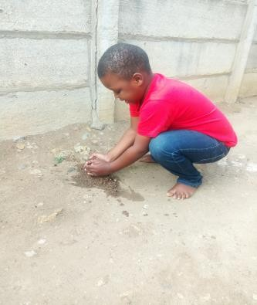

A clay. B clay loam. C sand. D None of these

42 Human beings can improve the water cycle by A afforestation. B deforestation C using magic. D seeing a dam

43 Which crop should be included in any rotation A fruit. B leaf. C root. D legume

44 When water falls to the ground in the form of ice it is called A thunderstorm. B strong showers C drizzle. D hail

45 Select a set of tools suitable for stamping trees in orchard

A pick and shovel B how and spade. C mattock and shovel D axe and shovel 46 Poultry and rabbits are cheap source of

A carbohydrates. B vitamins. C fats. D protein

47 Which of the following plants is not in the class of cereals? A maize. B rice C sunflower. D sorghum

48Which of the following is not a method of reproducing new plants? A budding. B grafting. C layering. D flowering

49 Which of the following people should be supplied with protective clothing A School. B school girl. C farm labourer. D school prefect

50 Natural farming regions are also called

A highveld. B middle veld. C low veld D the escarpment

EXAMINATION 7

**PAPER 2 (2 hours) SECTION A**

There are six questions in this section. You are advised to spend not more than 75 minutes on this section.

1(a) Copy and complete the table of weather elements below.

|  |  |
| --- | --- |
| WEATHER ELEMENT | INSTRUMENT |
|  | Hygrometer |
|  | Cup anemometer |
| Temperature |  |
| Rainfall |  |

(b) Wind speed is measured in. (1).

[Total 5]

1. (a) Give two reasons why soil organisms are important to plant growth. (2)
   1. List two examples of soil living organisms. (2)
   2. Why is it important to add organic matter to the soil? (1)

[ Total 5]

1. (a) Explain any two causes of each of the following:
2. physical weathering
3. chemical weathering. (4)

(b) Name the part of the plant mostly active in biological weathering. (1) [ Total 5]

1. (a) List two methods that a farmer can use to protect field crops from competition for soil nutrients by weeds. (2)
   1. Name three methods used by farmers to conserve moisture in the soil. (3).

[Total 5]

1. Match the processed materials listed here to farm produce below: ( mealie meal, bread, juices, sugar, clothes)
2. Cotton.
3. Citrus fruits.
4. Wheat.
5. Sugarcane
6. Maize. [ 5]
7. (a) State the nutritional value for each of the following: i) legume crop. ii) cereal crop. (2)
   1. The loss of nutrients down by drainage is called. (1)
   2. List two factors that influence the process of evaporation. (2) [Total 5]

SECTION B

Answer any two questions. You are advised to spend not more than 45 minutes on this section.

1. Explain the management practices that are carried out for either rabbit or poultry. [Total 10]
2. (a) If you walk around the school ground after a heavy rainfall, what sign of soil erosion do you observe? (5)
   1. Your class was asked to find ways of controlling soil erosion on the school ground, identify ways you would use? (5)

[ Total 10]

1. Explain how you would grow a leaf vegetable using the following headings.
2. name of the leaf vegetable. (1)
3. planting time. (2)
4. tools needed. (2)
5. five operations you would Carry out to care for the leaf vegetable. (5)

[Total 10]

1. (a) Describe how farmers can establish a tree nursery. (4)
   1. Explain how trees are planted and cared for. (6) [ Total 10]

EXAMINATION 8

**PAPER 1 (2 hours)**

ANSWER ALL QUESTIONS IN THIS PAPER.

1Study the diagram below which brand of agriculture uses this item?

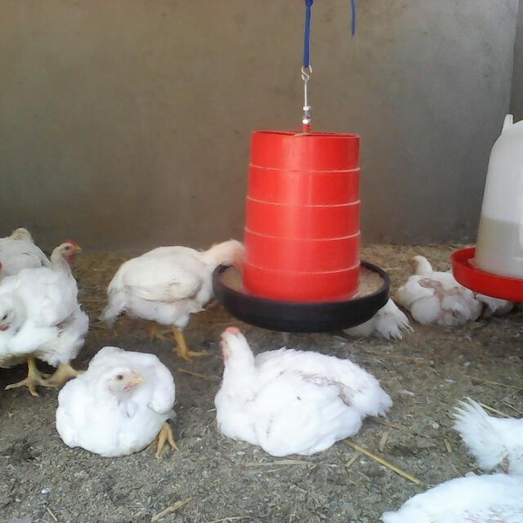

A Animal production. B crop production.

C Agriculture engineering. D Agricultural economics

2 What do we call a planned statement in how money is spent on a specific activity? A record. Budget. C inventory. D farm diary

3Shifting cultivation falls under which type of agriculture? A monoculture. diversified

C subsistence farming. D commercial farming

4 From the following, which one can be used as poultry feed? A Pellets. B Pig concentrate. C Humus. D Mulch.

1. Peas and beans belong to which family of vegetable? A Bulbs. B Root vegetables. C Legumes. D Fruits.
2. Which time of the year are trees pruned? A Spring. B winter C Summer. D Autumn.
3. What do we call the swelling on roots of certain plants? A Nitrogen. B Humus. C Organisms. D Nodules.
4. Hail is......... A solid precipitation. B liquid precipitation. C the moisture in the atmosphere. D water in the river.
5. Animals kept for food will produce more if they get enough clean. A room.

B food. C food and water. D feeders.

1. The following diagram shows linkages of a farm as a system: INPUTS X OUTPUTS.

which part is missing in that system diagram? A Profits. B Exports. C Process. D Procedures.

1. Soil moisture returns to the atmosphere through the process of A evaporation. B infiltration. C respiration. D transpiration.
2. Which of the following is a farming input? A Profit. B Fertilizer. C Floods. D Yield.
3. What work is done by agricultural engineers? A Telling farmers the best type of soil to plant. B Making and repaired machinery. C Treat animals on farms. D Provide security for the farm.
4. The rainfall for region one is............... A 600mm. B 1000mm. C 400mm. D 250mm.
5. Choose a drought resistant crop from the following. A Maize. B Groundnuts. C Sorghum. D Wheat.
6. An example of fertilizer applied to maize plant is A compound D. B gypsum. C lime. D mulching grass.
7. Use of implements in agriculture helps to A employ more workers. B make work easier. C reduce the yields. D promote weed developing.
8. Perforated pipes are used to A increase water pressure. B conserve nutrients. C direct drip irrigation. D absorb oxygen.
9. A farming system has natural, economic and social inputs. Which of the following is an economic input? A Rain B Solar. C Seed. D Labour.
10. Insects that feed and live on other animals are called A pests. B hosts. C parasites. D guests.
11. How does hot weather conditions affect crops? A It causes water logging. B It's causes wilting. C It causes pollution. D It causes frost attack.
12. What is weather? A It is the amount of rainfall received in a certain area.

B It is precipitation in a form of hail. C It is the condition of the atmosphere at a given time. D It is wind speed at a given day.

1. Small livestock are kept at home to A protect them. B control diseases. C provide food. D attract tourists.
2. A system of housing individual laying birds is called a A battery cage. B fold unit. C free range. D deep litter.
3. Which of the following is a draught animal? A Cat. B Donkey. C Sheep. D Pig.
4. The biggest dam in Zimbabwe is A Mutirikwi. B Kariba. C Lake Chivero. D Tokwe Mukosi.
5. Soil cultivation A adds organic matter. B conserve moisture. C retains air. D absorbs nutrients.
6. The green triangle label on a pesticide container means A dangerous. B caution. C extremely poisonous. D hazardous.
7. Rainfall 700mm-1000mm, temperature 16-18°C, production of maize, groundnuts, tobacco as well as beef and dairy production. These are characteristics of region

A 1. B 2. C 3. D 4.

1. Which sequence of activities shows a change of seasons and activities? A weeding, harvesting, shelling, gardening. B harvesting, gardening, weeding, shelling. C ploughing, gardening, shelling, planting. D shelling, planting, gardening, harvesting.
2. An energy source that do not cause global warming is A bioenergy. B chemical energy. C thermal energy. D firewood.
3. When water vapour changes to clouds, we call this A evaporation. B transpiration. C condensation. D respiration.
4. Which soil component increases water content of the soil? A Mineral matter. B Air. C Organic matter. D Living organisms
5. The main type of irrigation used in growing wheat is A flood. B overhead. C drip. D natural.
6. Changing crops on the same piece of land year after year is A mixed farming. B inter cropping. C crop rotation. D division of crops.
7. One maintenance of the wheelbarrow is A carry stones. B carry water. C lubricate with oil. D leave it outside.
8. In which way is water cycle disturbed. A cutting down trees. B building dams. C growing trees. D burning grass.
9. Chirinda forest is popular for it's . A pine trees. B indigenous trees. C exotic trees. D wattle trees.
10. Disposing waste anywhere on the ground result in A death of people. B soil pollution. C soil erosion. D soil texture.
11. A grade seven learner went to the garden and tied leaves in a clear plastic as shown on the photograph. The next day they saw some watering droplets. What process were they investigating?

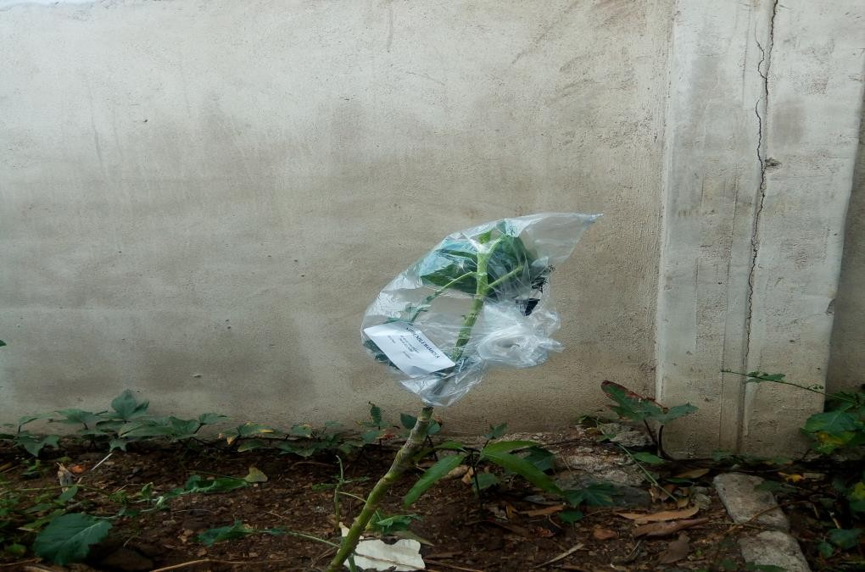A

Evaporation. B Transpiration. C Oxygen. D Condensation.

42 what is common name for nematodes? A Red spider. B Stalk borer. C Tick. D Eelworm.

1. A method of controllable internal parasite is A dusting. B dipping. C spraying. D deworming.
2. Which one is a sign of Newcastle in poultry? A Sleeping. B Scratching. C Coughing. D Mucus discharge.
3. Supply refers to A low prices. B high prices. C seasonal changes. D availability of products.
4. The government of Zimbabwe makes sure that enough food is produced by increasing A cost of inputs. B cost of fuel. C access to inputs.

|  |  |  |  |
| --- | --- | --- | --- |
| D employment opportunities. |  | | |
| 47. The confectionery industry makes D bread. | A fabrics. | B shoes. | C chemicals. |
| 48. To which class of plants does the coffee C Biennial. D Seasonal. | belong? | A Perennial. | B Annual. |

1. When the supply of tomatoes on the market is high the price will be A the same. B high. C low. D double.
2. Some crops which are grown for food produce grains and are called A lint B fibres. C cereals. D pellets.

**EXAMINATION 8**

**PAPER 2 SECTION A**

There are six questions in this section. You are advised to spend not more than 75 minutes on this section.

1. (a) Give two advantages for each of the following: (i) mixed farming. (ii) specialized farming. (4)
   1. What is horticulture? (1)

[ Total 5]

1. (a) Name one crop and one animal which provides fibre for making clothes. (2)
   1. Explain three ways in which rainfall can affect agriculture. (3) [Total 5]
2. (a) complete

|  |  |
| --- | --- |
| **TOOL** | **CLASS** |
| ………………………… | Cutting tool |
| Pick | ………………………… |
| …………………………. | Watering tool |

* 1. Name the tool that is able to dig and turn the soil. (1)
  2. Which tool is suitable to harvest a crop like rice? (1)

[Total 5]

1. (a) List two ways of caring for trees. (2)
   1. State the importance of growing trees around field crops. (3)

[Total 5]

1. (a) Name two edible products of animals. (2)
   1. Name two domestic animals. (2)
   2. Give one example of poultry. (1)

[Total 5]

1. (a) The two elements of weather are..... and. (2)
   1. Name the product we get from: (i) cattle. (ii) sheep. (iii) chicken. (3)

**[Total 5] SECTION** B

Answer any two questions. You are advised to spend not more than 45 minutes on this section.

1. (a) How best can you conserve water in the home? (2)
   1. Which field crops need to be raised on the nursery first? (2)
   2. State the three benefits of agriculture at community level. (3)
   3. Why is soil air very important in agriculture? (2)
   4. Give an example of organic manure. (1)

[Total 10]

1. (a) Explain the importance of tool issue record. (1)
   1. State the disadvantages of extensive housing system. (3)
   2. Describe intensive housing system of keeping animals. (3)
   3. What is the difference between domestic and wild animals? (2)
   4. Why is it important to keep the records of the company that supplies your day old chicks? (1)

[Total 10]

1. (a) State two functions of a flower. (2)
   1. Give two deficient symptoms of potassium in plants. (2)
   2. Using potatoes, field beans and wheat, draw a three field crop rotation for three years. (6)

[ Total 10]

1. Your class wants to start a poultry project.
2. Identify the materials used as bedding for broilers. (3)
3. Identify the feeds used to feed broilers. (4)
4. Identify the local markets for the broilers. (3) [total 10]

EXAMINATION 9

**PAPER 1 (2 hours)**

ANSWER ALL QUESTIONS IN THIS PAPER.

1. Using the hand to produce crops and to keep animals is ------------------------ A horticulture B engeneering C agriculture D economics
2. Agriculture has major parts

A 2 B3 C4 D5

1. The three main groups of farmes in Zimbabwe are--------

A large-scale, small scale and peasant

B lager-scale, peasant, command

C large scale, small scale, peasant, command

D large scale, small scale, commercial

1. The care of farm machinery, tools, farm buildings water supplies and irrigation is -----

A horticulture B animal husbandry C agricultural engineering D agriculture economics

1. Most staple foods are rich in which nutrients? A protein B carbohydrates C vitamins D fats
2. Forestry, fruits, tea and coffee are produced on large scale in which farming region? A 1 B 2 C 3 D 4
3. Stations such as Grasslands, Henderson, matopos and Inyanga experimental farms are used for

A research B markets C banking D co-operations

1. Which one of the following is **NOT** a straight fertilizer or single fertilizer ?

A Urea B double superphosphate C potassium chloride D compound D

1. A harrow is used for -------------

A cutting B Loading heavy goods C braking up rough soil surfaces D planting seeds

1. One characteristics of grass crop plants is that-----------------

A they shed leaves in winter. B they have parallel veins C they are legumes D they are all drought resistant

1. Which city is in the Eastern Highlands?

A Harare B Masvingo C Mutare D Bulawayo

1. The tillage practice of planting seed on unploughed land is ---------- A fallow B rotational C Minimum D convectional
2. In Zimbabwe how many natural farming regions do we have? A 10 B5 C4 D 3
3. The soil in which we grow our crops comes from rocks by a process called A respiration B photosynthesis. C weathering D germination
4. Zimbabwe is situated between------and south latitudes and lies within the

tropics that affect its climate.

A 0 degrees, 33 degrees B 10 degrees , 0 Degrees. C 15,5 Degrees, 22,5 degrees

D 0 degrees, 45 degrees

1. What is weather?

A air with fine droplets of water

B layer of air above the ground in atmosphere

C conditions of the atmosphere at a particular place and time

D the seasons of an area over period of time

1. How are external worms controlled in farm animals? A vaccination B dosing C Disinfection. D dipping
2. How much Drug is needed for 20 litres if the dilution rate in 5g per 5 litres of water? A 10g B 20 g C 100g D 25g
3. Plant roots, earthworms, termites, the sun and organic matter are ------------

A agents of soil formation B agents of soil erosion C agents of weather. D vegetation

|  |  |  |  |
| --- | --- | --- | --- |
| 20. What is topography? | A movement of water | B movement of the soil | C |
| top layer of the soil | D slope of the land |  |  |

1. Red clay soils which are rich in nutrient content come from which rocks? A basalt B Serpentine C Dolerite D Granite
2. How do small organisms influence vegetation?

A they cause faller leaves and branches to decay

B they cause soil erosion

C they are habitats

D they move rock fragments

1. When rains falls, the water that runs along the surface is known as A

precipitation B leaching C run-off D Condensation

1. The process by which rain water carries its soluble salts from the surfaces to the sub soil is ----------

A percolation B seepage. C Leaching D runoff

1. Which climatic hazard is controlled by building dams or water harvesting A frost B wind C drought D water logging
2. A farmer who grows crops and keeps animals for personal use or domestic use is a framer

A peasant B Traditional C Subsistence D commercial Study the table below and answer questions 27 and 28

|  |  |
| --- | --- |
| A | 1200mm rainfall |
| B | 800mm rainfall |
| C | 1000mm rainfall |
| D | 300mm rainfall |

1. Which area is suitable for tobacco growing?
2. Irrigation schemes are mostly found in which areas? In region…… A 1 B 2 C 4 D 5
3. “’Low temperatures, little rainfall and famers plant wheat under irrigation’’ which season is this?

A hot, wet season B post rainy season C Hot season D cool dry season

1. Sandy loam soils that contain nickel and chromium salts are harmful to plant growth. In which area do we find these in Zimbabwe?

A Harare. B Great dyke region. C Eastern regions. D Mutoko

1. A typical soil composition would have above % solid including organic matter

A 25 B 35 C 40 D 50

1. Soil structure refers to the ----------------

A size distribution of sand, clay, and silt particles in the soil

B way the soil particles are arranged with respect of one another

C vertical cross section of the soil showing horizons

D the amount of soil in a field

1. A soil profile refers to the

A amount of soil in the field

B vertical cross section of the soil showing horizons

C way the soil particles are arranged with respect to one another

D size distribution of sand, clay and silt particles in the soil

1. A farmer applied ammonium nitrate at the rate of 200kg per hectare. How much ammonium nitrate is needed in a field with an area of 3 Ares

A 2kgs B 4KGS C 3KGS D 6KGS

1. Farmers can retain moisture in a vegetable bed by------

A evaporation B Irrigation. C mulching. D transpiration

1. The green colouring of leaves on plants is called------

A Chlorophyll B Translocation C Greening D Photosynthesis

1. An agricultural activity which causes water pollution is ------- A use of agrochemicals

B acid rain

C sewage waste

D industrial waste

1. What is cloud seeding?

A putting seeds in containers B Throwing seeds in the sky C using chemicals to produce rainfall D covering seedbeds with shades

1. Which soil type sticks on the hoe during weeding? A Sand B clay C Loam D silt
2. Which state of water is used for farming? A ice B gas C solid D liquid
3. Which mineral is responsible for teeth formation in animals? A nitrogen B Potassium C calcium D magnesium
4. Which of the following is a legume? A okra B Tomatoes C rape D peas
5. Fodder is food for?

A cattle B Fish C rabbits D chickens

1. Money used to start a business is called ------- A investment B Capital C Profit D rent
2. If three man can thatch an implement shade in nine days , working at the same rate nine man need -----------days A 18 B 3 C 27 D 10
3. A good crop rotation has the following

A leafy vegetable, fruit vegetable, root crop and legume

B maize, wheat, sorghum and rice

C cabbage, lettuce, spinach and pepper

D leafy vegetables, fruit trees, root crops and legumes

1. All farm assets are recorded in the --------

A crop record B livestock record C labour record D inventory

1. Where do deciduous fruit trees grow well?

A in hot areas B in areas with cold winters with more frost C in cool areas D in water logged areas

1. A farming business run by one person is called

A partnership B Cooperative C sole trader D subsistence

5 0. In the month of March 2017 a farmer had 100 layers that produce 93 eggs. Calculate the percentage of production

A 93 B 7 C 193 D 3

**EXAMINATION 9**

**PAPER 2. SECTION A**

There are six questions in this section. You are advised to spend not more than 75 minutes on this section

1. What are ornamental plants? (1)

|  |  |  |
| --- | --- | --- |
| 1. An example of a field crop is.... and a garden crop is....... 2. Why do we sharpen tools? (1) |  | (2) |
| 1. Give any two examples of agrochemicals. (2) 2. What is used to measure humidity and wind speed? | (2) |  |
| 1. Zimbabwe is divided into main natural farming regions. 2. Give one function of water in the soil. (1) 3. Name one agent of weathering. (1) 4. The main cause of soil pollution is. (1) 5. Name one use of mulch. (1) |  | (1) |

11. What do you understand by the term permaculture? Give examples. (2)

|  |  |  |
| --- | --- | --- |
| 1. Name two human activities that cause soil erosion. (2) 2. List two water borne diseases caused by drinking dirty water. (2) 3. Give two classes of vegetables. (2) |  |  |
| 1. Name one way of harvesting tomatoes. 2. What is a pest? (1) 3. List two vegetable pests you know. (2) 4. Name two cereal crop | (2) | (1) |
| Another word for varieties is.........  SECTION B | (1) |  |

Answer any two questions. You are advised to spend not more than 45 minutes on this section.

1. Complete giving examples Leaf ...........

Legume ...........

Fruit ............

Bulb ............

Root (5)

1. A) Name three things to consider when choosing an orchard site. (3)
2. List a product you can make from on orange. (1)
3. Name one tree that can be grafted. (1) (5 marks)
4. A)

COLOUR CODES. MEANING PURPLE.. . .. .....

RED.. .......

ORANGE. (3)

1. Name a weed that is said to be paralytic or that feeds from other plants. (1)
2. What are perennial weeds? (1) (5 marks)
3. A) Why are animals important? (1)
4. List two by-products form animals. (2)
5. Name one of the endangered species. (1)
6. Name one use of animal skin.

(5 marks)

1. A) Why do small livestock need housing? (1)
   1. Name two types of housing systems for poultry. (2)
   2. Housing system for rabbits is a (1)
   3. The giving birth of rabbits is known as (1)

(5 marks)

6 A) Name two examples of tractor drawn implements. (2)

7. Draw and label a mouldboard plough. (5)

EXAMINATION 10

**PAPER 1 (2 hours)**

**ANSWER ALL QUESTIONS IN THIS PAPER**

|  |  |  |
| --- | --- | --- |
| 1. Agriculture is best described as |  | |
| A growing of crops | B | rearing of animals |
| C Growing of crops and rearing of animals |  | D digging of |
| the land  2. Which tool is suitable for harvesting wheat? |  |  |

A sickle B rake C hoe D an axe

1. Agriculture is important to the wealth of Zimbabwe because
   1. People will get diamonds
   2. young children will obey their parents
   3. a country can earn foreign currency through exports
   4. all young generation will be farmers
2. What name is given to plants grown for beautification?

A ornamental plants B orchard C plantation D veld

1. A farmer who grows crops and keeps animals for his family called farmer.
   1. skilled B peasant C commercial D semi – skilled
2. An example of an animal that is important for both meat and power is a
   1. donkey B horse C goat D ox
3. In Zimbabwe, the cool season is from
   1. mid March to mid May B mid May to August

C September to mid November D mid November mid March

1. In Zimbabwe, how many farming regions are there?
   1. 1 B 5 C 9 D 10
2. How do agricultural tools classified? According to
   1. use B the owner C the colour D strength
3. In a storeroom, where should tools be put?

A on a rake B on the floor

C heaped on one place D thrown all over the storeroom

1. An advantage of intercropping is that it

|  |  |  |
| --- | --- | --- |
| A controls erosion | B | makes people lazy |
| C increases deforestation | D | offers high income base |

1. The purple triangle on a chemical container indicates

A caution B extremely dangerous C dangerous D hazard

1. High temperatures, high rainfall and farmers grow field crops. Which season is being

described.

A hot wet season B post rain season

C cool dry season D hot season

1. John was playing with soil. He found out that the soil was sticky and water could not drain

easily. Which soil was that?

A clay B loam C sand D silt

1. The breaking down of rocks to form soil is called

A crushing B decaying C erosion D weathering

1. Living organisms in soil help to

|  |  |  |
| --- | --- | --- |
| A decay organic matter | B | keep moisture in the soil |
| C break rock and stones | D | keep away pest and diseases |

1. Which one of the following is not a weathering agent?

A temperature changes B grazing animals

C freezing water C wind

1. A child sets up an experiment as shown below. He pours water in the soil.



Water

Bubbles Soil

Which soil component is shown by bubbles coming out of the soil?

A air B moisture C organic matter D mineral matter

1. Which of the following list contains plant nutrients?

|  |  |  |
| --- | --- | --- |
| A nitrogen | hydrogen | oxygen |
| B nitrogen | chlorine | potassium |
| C Nitrogen | phosphorus | potassium |
| D nitrogen | carbon – dioxide | potassium |

1. Soil moisture returns to the atmosphere through the process of A evaporation B infiltration C respiration D transpiration
2. In agriculture, which liquid is regarded as a precious liquid?

A water B cooking oil C paraffin D diesel

1. Water conversation is the practice of

|  |  |  |
| --- | --- | --- |
| A using water wisely | B | using water consistently |
| C using clean water | D | taking water to drink |

1. Identify a tool suitable for harvesting groundnuts from the following tools. A hoe B spade C pick D fork
2. Which state of water is used in farming

A solid B liquid C gas D cloud

1. Which one of the following is a root vegetable?

A potatoes B Rape C cabbage D tomato

1. Select the part that carries water up the plant.

A stem B leaves C branches D fruit

1. Transfer of pollen grains from male to female parts of a flower is called

.

A chlorophyll B transpiration C pollination D propagation

1. Plants protect the soil by

A binding particles B providing shade

C producing sewn timber D providing firewood

1. Which method do farmers use to conserve moisture in the soil ?

A transplanting B staking C mulching D fertilization

1. Young vegetables and tree seedling are raised in

A a river B an orchard C a dam D a nursery

1. The use of cuttings is a method of reproduction whereby
   1. Pruning is done to a tree
   2. Seed is put into the soil to grow another plant
   3. A part of a plant is cut and plant into the soil to produce a new plant
   4. a part of a plant is grateful into another plant
2. Which animals provide people with wool?
   1. horses B dogs C sheep D cattle
3. Choose a reason for housing poultry.
   1. so that they will eat less food
   2. to provide protection from predators
   3. to attract tourists into the country
   4. for them to be cheap
4. At the end of ploughing season, an ox – drawn mouldboard plough, scotch cart, cultivator

and harrow should be kept in

* 1. a field B a shed C open space D the soil

1. Which mineral is responsible for teeth formation in animals?
   1. nitrogen B potassium C calcium D magnesium
2. Which branch of agriculture is responsible for the buying and selling of farm produce?
   1. crop production B animal production

C soil science D Agricultural economics

1. Which of the following professions falls under semi – skilled work? A mechanics B repairing electrical faults

C driving a farm tractor D treating animal diseases

1. Grade seven pupils went to the orchard and tied leaves in a clear plastic paper. The next day

they saw some water droplets. What process were they investigating?

A transpiration B evaporation C respiration D percolation

1. Farm equipment is painted to

A make it strong B. prevent termite attach C clean dirt D reduce rust

1. The coarseness or fineness of the soil is called
   1. pH B structure C profile D texture
2. Which one of the following is an industrial use of water?
   1. drinking B cooking C bathing D electricity generation
3. A form of farm machinery that can be used for ploughing is a
   1. tractor B combine harvester C harrow D hoe
4. When income is bigger than expenditure then the farmer has made a
   1. loss B good money C profit D credit
5. Which record book shows date, name and number of tool, name of a person and signature?

A. record book B inventory C farm register D. tool issue record

1. All tools on a farm are recorded in a book called

A. tool register B inventory C farm register D expenditure account

1. Why was land reform programme introduced in Zimbabwe?
   1. to give back land to the rightful owners
   2. so as people can sell the land
   3. so as to make football pitch
   4. none of the above
2. Climate change as a problem is caused by
   1. weeding B deforestation

C planting trees D streambank cultivation

1. A person who sells farm produce at the market is a
   1. vendor B consumer C businessman D storekeeper
2. A farmer bought inputs for $150 when raising chicken. He paid the workers $70. What profit did he make if he sold the chickens for $300?

A $70 B $80 C $300 D $40

1. Where are cereal crops marketed?
2. grain marketing boarding
3. cotton marketing board
4. agriculture finance corporation
5. Agribank

**EXAMINATION 10**

**PAPER 2 SECTION A**

There are six questions in this section. You are advised to spend not more than 75 minutes on this section.

1a. Agriculture is the study of crops

and animals. (2)

1. Give one importance of Agriculture.

. (1)

1. Long ago people were...........................................................

and (2)

2a. Name any one basic farm tool which can be used in the

garden. (1)

[5 marks]

1. Give the uses of the following tools.
   1. pick (1)
   2. watering can. (1)
   3. hoe (1)
2. What should be worn when spraying chemicals?

. (1)

[5

marks]

3a. How many season are there in a year? (1)

1. Large amounts of rainfall are received in ..................................

.season. (1)

1. In which season is wheat grown? (1)
2. The other name for cold season is (1)
3. December is in which season? (1)

[ 5 marks]

4a. Name any two types of soil.

......................................... and (2)

1. Which type of soil has smallest particles?

. (1)

1. ................................................ sticky when wet soil. (1)
2. Which type of soil rough when you rub it?

. (1)

[5 marks]

5a. What is soil erosion? ....................................................................

. (1)

1. Name any two agents of soil erosion.

.................................................... and (2)

1. State any one cause of soil erosion.

. (1)

1. Soil with grass cover is protected from erosion.( true, false)

. (1)

[5 marks]

6a. Name any one use of water in Agriculture.

. (1)

1. What is a habitat? ..................................................................

. (1)

1. State any two natural sources of water.
   1. ...........................................................................................................
   2. (2)
2. Borehole is a natural source of water. (true, false)

.................................................................................... (1)

SECTION B

**Answer any two questions. You are advised to spend not more than 45 minutes on this section.**

7a. Name any one cereal plant product which you know.

. (1)

1. Gumtree is used in medicine. (1)
2. Ornamental crops are used for ..................................................

purposes. (1)

1. Name any one cultivated plant. .................................. (1)
2. is the staple food for Zimbabwe.
3. Where are vegetables usually grown?

. (1)

1. Give one example for the following classes of vegetables.
   1. leaf vegetable (1)
   2. root vegetable (1)
2. Carrots belong to which class of vegetables?

. (1)

1. Cabbages belong to which class of vegetables?

. (1)

[10 marks]

8a. What is transplanting of seedlings? ..........................................

. (2)

1. The other name for a seed bed is

. (1)

1. Which tool is used for levelling a bed/

. (1)

1. Which tool is used for watering vegetables?

. (1)

1. What is an indigenous tree? .................................................

. (1)

1. Name one example for each of the following.
   1. Indigenous tree

......................................................................................................

* 1. Exotic tree

......................................................................................................

1. A place where fruit trees are grown is called a

. (1)

1. Another name for eucalyptus tree is

. (1)

1. Name any one citrus fruit tree.

. (1)

[10 marks]

9a. What is a domestic animal? ...................................................

. (1)

1. Give two examples of wild animals.

................................................. and (2)

1. Give one importance of animals in our lives.

. (1)

1. Why is a rat not a domestic animal? ........................................

. (1)

1. Give one reason why plants need water?

. (1)

1. Why are trees important to human life? (4)

EXAMINATION 11

**PAPER 1(2 hours)**

ANSWER ALL QUESTIONS IN THIS PAPER

1. Which one is not a career in agriculture? A Agronomist. B Pharmacist. C Soil scientist. D Veterinary doctor.

2 Which is not under specialized farming?

A monoculture. B dairy farming C inter cropping D coffee plantation 3Growing flowers for export is practised in which branch of agriculture?

A Agriculture economics B soil science. C crop production. D animal production 4Which one of the following is a staple food in Zimbabwe?

A wheat. B rice C maize D potato 5Which fuel is obtained from agriculture? A petrol. B paraffin. C gas. D ethanol

6A tool which is best for use in digging gravel soil is a. A garden fork. B pick C mattock. D ethanol

7Select a nutrient needed for increasing crop yeild A calcium. B hydrogen. C potassium. D nitrogen

8Which of these was the earliest system of trading in agriculture?

A barter trade. B marketing. C rainfall. D Exchanging for money.

1. An example of A 2 farmer is under A subsistence farming. B small scale commercial. C cooperation farming. D large scale commercial farming.
2. When you pour water in a sample of soil in a jar, A organic matter will escape. B air will escape. C water will escape. D living organisms will escape.
3. An example of deciduous fruit tree is A orange. B lemon. C nartjies. D peach.
4. What comes after clouds in the water cycle? A Transpiration. B Rainfall. C Infiltration. D Evaporation.
5. Which one is a form of precipitation? A Rainfall. B Wind. C Temperature. D Humidity.
6. An earthworm and is one of the soil living organisms. Why is it important to the soil? A It improves soil fertility by burrowing in leaves. B It is like a snake. C Some people use it for fishing. D Earthworms are also called macro organisms.
7. The main cause of erosion in winter is A ice. B wind. C water. D pressure.
8. Game ranching is practised in which branch of agriculture? A Animal production. B Crop production. C Soil science. D Agricultural economics.
9. The sale of chickens is an example of A process. B output. C economic inputs. D human inputs
10. Which of the following best describes agriculture. A Keeping animals for sale only. B Buying and selling agricultural products. C Subject taught at grade seven. D Growing crops and keeping animals.
11. Global warming is caused by greenhouse gases such as A oxygen. B carbon dioxide. C air. D water.

|  |  |  |  |
| --- | --- | --- | --- |
| 20. Generally high altitude places are D very warm. | A very hot. | B cooler. | C very dry. |
| 21. An example of perennial vegetable is cabbage. | A covo. | B beans. | C peas. D |

1. How does very high temperatures affect animals and plants? A Flooding and erosion. B Water logging wilting. C Washing away of soil. D Wilting and dehydration.
2. Tomato plants should be supported because they have A large fruits. B green leaves. C many branches. D weak stem.
3. Which part of the plant usually causes rocks to crack? A Leaves. B Stem. C Branches. D Roots.
4. Which type of weathering has the following agents, tree roots, animal hooves, people and his tools? A Physical weathering. B Chemical weathering. C Biological weathering. D Cold weathering.
5. Leaf vegetables include all of the following EXCEPT A sugar loaf B rape. C carrots. D spinach.
6. Chemicals such as acids dissolve parts of rocks and stones in the process of............ weathering. A artificial B temperature C physical D chemical
7. Which soil can easily get waterlogged? A Silt. B Sand. C loam. D Clay.
8. A woodlot should be protected from livestock through A weeding. B irrigation. C fencing. D chemicals.
9. High places receive A high rainfall. B low rainfall. B moderate rainfall. D no rainfall.
10. Climate change is caused by A evil spirit. B God's punishment. C human activities. D nature.
11. Which property of soil cannot be altered by farmer's activities? A aeration. B Texture. C Structure. D fertility.
12. Polluted soil is mostly A fertile B rich in organisms C unproductive. D good for plant growth.
13. In farming system, buying vegetable seeds is an example of A inputs. B outputs. C process. D feedback.
14. Flammable chemicals are chemicals which A are very expensive. B are easy to get rid of. C easily catch fire. D are approved by the government.
15. Soil with good structure is A hard to work. B easy to work. C very dry. D very wet.
16. Lurcene and clover are forage plants. Which nutrient do these plants provide to livestock? A Fats. B Minerals. C Carbohydrates. D Proteins.
17. Identify a grain storage pest from the following: A Stalk borer. B Locust. C Aphids. D Weevils.
18. Irrigation is most common in the Lowveld of Zimbabwe. This is because the area is A cold. B dry. C wet. D hot.
19. How much money did the farmer require to run the farm business when he made a profit of $350 from the selling of vegetables worth $850? A $300. B $500.

C $800. D $1200.

1. Which plant disease is caused by both bacteria and fungi? A Black rot. B Grey leaf spot. C Streak. D Blight.
2. A form of farm machinery that can be used for farming is a A tractor. B combine harvester. C harrow. D hoe
3. When income is bigger than expenditure, then the farmer has made a A loss. B good money. C profit. D credit.
4. Which record book shows date, name, and number of tool, name of a person and signature? A Record book. B Inventory. C Farm register. D Tool issue record.
5. All tools on a farm are recorded in a book called A tool register. B inventory. C farm register. D expenditure account.
6. Why was land reform program introduced in Zimbabwe? A To give back land to the rightful owners. B So as people can sell the land. C So as to make football pitch D None of the above.
7. Climate change as a problem is caused by A weeding. B deforestation. C planting trees. D stream bank cultivation.
8. A person who sells farm produce at the market is a A vendor. B consumer. C businessman. D storekeeper.
9. A farmer bought inputs for $150 when raising chicken. He paid the workers $70. What profit did he make if he sold the chickens for $300? A$70. B $80. C

$300. D $40.

1. Where are cereal crops marketed? A Grain Marketing Board. B Cotton Marketing Board. C Agriculture Finance Corporation. D Agribank.

EXAMINATION 11

**PAPER 2**

**Section A – Answer all questions in this section**

* 1. (a) What is agriculture? (1)
     1. Give three career opportunities found in agriculture. (3)

© Which branch of agriculture deals with the maintenance of roads? (1)

* 1. (a) State one advantage and one disadvantage of mixed farming over specialized farming. (2)
     1. Colour codes on containers of agrochemicals have meanings. What do these colour codes mean?

Purple

(i)

(ii)

Orange

(iii)

Red

* 1. (a) Explain the following and give an example for each.

1. Unskilled worker
2. Skilled worker
3. Semi skilled worker

(b) Outline two precautions to be followed when using chemicals.

* 1. (a) Zimbabwe is divided into how many farming regions?

(b) What aspects are observed to classify farming regions?

© Which farming region is suitable for cattle ranching?

(d) Give one example of an area which is in region I Total 5

|  |  |  |
| --- | --- | --- |
| 1. (a) Name the four major components of soil.   (b) Which soil is suitable for vegetable growing?   1. (a) What is the difference between climate and whether ? | (4)  (2) | (1) |
| (b) What is regarded as a major cause of climate changes?  (c) State any one crop which is sensitive to frost when growing in winter. | (1) | (1) |
| (c) Give 3 advantages of organic manure to the soil. |  | (3) |
| 1. What enables farmers to grow wheat in winter? 2. Give four characteristics of a crumb. |  | (1) |

1. Give one example of a cereal crop.

Total 5

**SECTION B.**

Answer any two questions

|  |  |  |
| --- | --- | --- |
| 7. (a) How best can u conserve water in a home? | (2) |  |
| (b) Which field crops need to be raised on the nursery first?  © State any 3 benefits of agriculture at a community level. | (2) | (3) |
| (d) Why is soil air important in agriculture? |  | (2) |
| (e) Give an example of organic manure  8. (a) State three reasons why a budget is important. | (1) | (3) |
| (b) Explain the importance of a tool issue record. |  | (1) |
| © What is recorded on an income expenditure sheet? |  | (2) |

* 1. Name two other farm records you know. (2)
  2. Mr Jabu spent $350 on growing beans. He sold his beans for $450.
     1. Did he make profit or loss? (1)
     2. For how much? (1)

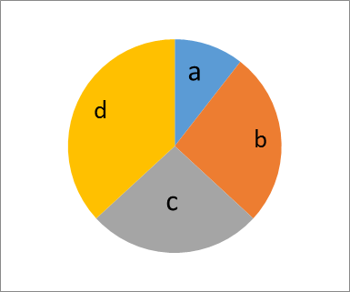

9. (a) The pie chart shows the soil components. Which components are labeled a, b, c and d?

1. Draw the plant and label all the main parts. (4)

|  |  |  |
| --- | --- | --- |
| (c) Give two cereals which are in a grass family. |  | (2) |
| 10. (a) Which fertilizer is used to top dress maize?  (b) what do you understand by banding of seeds? |  | (1) |
| (C) Give three advantages of organic matter. | (3) |  |

1. Give four characteristics of crumb structure of soil. (4)
2. What enables farmers to grow wheat in winter?(1)

EXAMINATION 12

**PAPER 1**

* 1. Agriculture is described as A growing of crops and keeping of animals.

B digging up the land. C providing food. D construction of farm buildings.

* 1. Which tool is suitable for harvesting wheat? A an axe B rake C sickle. D hoe
  2. Agriculture is important to Zimbabwe because A people will get diamonds

B young children will obey their parents. C a country will get foreign currency through exports D All young generations will be farmers.

* 1. Decorative plants are also called------ A. ornamental plants B cereals C. citrus D tropical.
  2. What do we call a farmer who grows crops and keeps animals for his or her family? A. skilled farmer B. peasant farmer C. commercial farmer D. semi-skilled farmer.
  3. A tool used for uprooting seedlings in a nursery is a A. trowel B. chisel C.

spade D. hand fork.

* 1. Which one is not an agricultural tool? A. garden fork B. teaspoon C. hand fork D. pick.

8 What is the function of a dibber? A to mark planting stations. B to dig deeply. C to make straight lines. D to make planting holes.

1. Agricultural tools are classified according to----.A their use B. the owner C. their colour D. strength.
2. The best type of soil for crop production is A. clay B. sand C. loam D. silt.
3. What is weather? A. air with fine droplets of water. B. a layer of air above the ground in the atmosphere. C Condition of atmosphere at a particular place and time. D Condition of atmosphere prevailing in an area over a period of time.
4. Hwange is in natural farming region

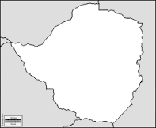

A 1 B 5 C.3 D. 4

1. High temperatures high rainfall and farmers grow field crops. Which season is being described? A Summer B Automn. C Winter D Spring
2. Floods can be caused by A too much rainfall. B too much humidity. C too much light. D too much wind.
3. The instrument below is used to measure



A wind speed B rainfall C wind direction D humidity

1. is the height above sea level. A humidity B latitude C altitude D weather
2. Which plant is mainly affected by frost? A wheat B rice C peas D tomatoes
3. The breaking down of stones to form soil is A decaying B crushing C weathering D erosion
4. Living organisms in the soil help to .

A break down organic matter B keep moisture in the soil C break rocks and stones D keep away pests and diseases

1. Tadiwa poured water in the soil and observed bubbles coming out of the soil. Which soil component was shown by the bubbles? A. moisture B. water C air D. loam
2. Which soil type sticks on the hoe during weeding? A. sand B clay C silt
3. Plants help in reducing soil erosion by-------. A. binding the soil B. growing in the soil C. breaking the surface of the soil D. using the soil nutrients.
4. Name the type of soil which has large particles A loam B. clay C. sand D

humus.

1. Which one of the following contains all plant nutrients? A. nitrogen, hydrogen and oxygen B nitrogen, oxygen and phosphorous C. nitrogen, phosphorous and potassium D. nitrogen, carbon dioxide and potassium.
2. Name the organic fertilizer. A urea B Compound C. Animal matter D. Ammonium nitrate
3. When rape leaves turn purplish it is a sign of lack of A. nitrogen B.

Phosphorous C. potassium D water

1. One of the following is a list of cash crops? A Beans, Maize and tobacco B. tobacco, cotton and tea C. maize , cotton and tobacco D beans, tobacco and cotton.
2. The National Tree Planting Day in Zimbabwe is on------. A 1 December B 7 December C. last Saturday of December D. First Saturday of December.
3. Transfer of pollen grains from male to female parts of a flower is called --.A.

chlorophyll B transpiration C pollination D propagation.

1. The table below shows the type of food needed by broilers. Complete the table.

|  |  |
| --- | --- |
| Age | Food |
| 0-4 weeks | Starter Mash |
| 4-5 weeks | Growers Mash |
| 5 weeks Slaughter | ------ |

A broiler starter mash B broiler mash C broiler finisher mash D layers mash.

31 Cattle ranching falls under which branch of agriculture? A crop production B. animal production C. soil science D. agricultural economics

1. Which animal provides people with wool? A dog B. cattle C. sheep D. horse.
2. Wild animals are important because they -------. A. cultivate forest B. destroy crops C kill people D. attract tourists
3. The term ‘small livestock’ commonly refers to---------- A. poultry and rabbits B. goats and sheep C. cats and dogs D. calves and puppies.
4. Why do farmers dip their livestock? A. to fatten them B. it is their way of bathing

C. to remove long hair D. to kill ticks.

1. How much ESB3 drug is needed for 30 litres of water if the dilution rate is 5g per 5 litres of water. A 25g B 30g C 20g D 100g
2. One way of maintaining a wheelbarrow is by------. A carrying stones B. carrying water C. leave it outside D lubricating it with oil or grease
3. What is the best place for storing our farm implements and machinery? A house

B. block C shed D outside.

1. A form of farm machinery that is used for tilling is ------ A. tractor B. combine harvester C. harrow D. hoe.
2. A spade is used for A. loading B. digging C. cutting D. carrying.
3. The purple triangle on a chemical container indicates.

PURPLE

A. Caution B. extremely dangerous C. dangerous D. may be harmful.

1. The best tool for sharpening blades is a------. A harmer B saw C. file D. secateurs
2. Which one of the following tools is used for spraying? A. knapsack sprayer B. hosepipe C. watering can D. fine rose.
3. A planter is used for A. harvesting B. planting C ploughing D. storing
4. A branch of agricultural responsible for buying and selling of farm produce is------

A. crop production B. animal production C. agricultural economics D. soil science.

1. Which one is a farm record? A. birth record B. production record C. baby card D. social record
2. A person who sells farm produce at a market is a --. A. consumer B. storekeeper

C. vendor D. farm engineer

1. Farmers harvest water in order to ---- A. mulch B. conserve C. evaporate D. dam
2. The state of water used for farming is ----- A. solid B. liquid C. gas D. ice
3. Use of agro chemicals may cause A. evaporation B. hail. C. siltation D

water pollution.

EXAMINATION 12

**PAPER 2 SECTION A**

**Section A – Answer all questions in this section**

1. (a) Agriculture is [1]
   1. Write 2 importance of agriculture. [2]
   2. How many branches of agriculture do we have? [1] (d)Agricultural engineering deals with [1]
2. (a) State any three seasons found in Zimbabwe. [3]
   1. Give units for measuring. (i) rainfall

(ii)Temperature. [2]

1. (a) What is a balanced diet? [1]
   1. Give two uses of animals in a community. [2]
   2. Name any two man made sources of water used by farmers. [2]
2. (a) Complete the table below.

|  |  |
| --- | --- |
| **TOOL** | **USE** |
| (i) Spade | A |
| (ii) Mattock | B |
| (iii)C | Cutting tool |
|  |  |

* 1. State any two materials which can be used to make farm tools.

1. (a) Give two examples of citrus trees.
   1. What is the difference between indigenous and exotic trees?
   2. State any use of trees.
2. (a) Name any two types of weathering. (b)Give any two agents of weathering.

(c) From the four components of soil, what is the composition with 5%?

**SECTION B**

Answer any two questions

1. Choose one vegetable crop and describe how it is grown. Use the following headings.
2. Name of vegetable.
3. Land preparation
4. Planting (d)Spacing (e)Harvesting
5. Give a pest that attacks the crop.
6. Describe the production of a small livestock animal using the following headings:
7. Name of animal
8. Care for the animal
9. Processing and marketing of the animal’s products and by products.
10. Your class has been asked to establish a woodlot.
11. Describe the factors which you will consider when choosing a site.
12. Care and maintenance of the woodlot
13. Give three importance of trees.
14. Mr Chida started his Quail Bird keeping project. Below is his income and expenditure account.

|  |  |  |  |  |  |
| --- | --- | --- | --- | --- | --- |
| **DATE** | **EXPENDITURE** | **AMOUNT** | **DATE** | **INCOME** | **AMOUNT** |
| **12/01/17** | Quail chicks | $100 | **11/06/17** | 100 crates eggs at $7  per crate | $ |
|  | 2 bags starter mash at $30  each | $ |  |  |  |
|  | 2 bags grower’s mash at $25  each | $ |  |  |  |
|  | 5 bags layers mash at $20  each | $ |  |  |  |
|  | Chemicals | $20 |  |  |  |
| **Total expenditure** | | $ | **Total Income** | | $ |

1. i) Complete the table by filling in the blank pages.

ii) Calculate the profit or loss made by the farmer.

1. Name any two records kept by a good farmer.

# GRADE 7 AGRICULTURE

## SECTION C

***ZIMSEC PAST EXAM PAPERS***



